**Daily Thoughts & Experience Diary**

**CS Challenges - Daniel Mackle 2024**

# **Day 1 - Monday 08/01/2024**

Hello World!

Caleb had told me that the specification needed a diary, and unsurprisingly, he was right!

Today, I looked over the options for my project, mostly just crossing out things that weren’t too interesting to me.

(Wow, are all the options equally interesting and scary)

Eventually, I ended up with a few, which I brought down to 4, and ordered them:

1. A2 Parameterised vector graphic faces
2. F2 Abstract syntax tree to source code creation
3. B3 Computer screen to a language and vision model
4. A3 AI Art for Icon Design

A2: “The goal of this is to use a 3d face and create a range of head poses and expressions and then use img2img to convert these posed heads to different cartoon representations and then vectorised the cartoon images to create a parameterised head representation for vtubing, comic and cartoon generation.”

I have (luckily) played around with AI generated text and art, both using models and training them, although mostly just consisting of using other programs to do the heavy lifting for me. All of my choices include interfacing with an AI, so That’ll be really interesting to do. I’m torn between A2 and F2, but A2 is more familiar to me. I don’t know much JavaScript though, so if I don't get A2 and F2 is in JavaScript, I’ll have to find another option.

I hope I get A2, though, because vectors are cool. But syntax trees are cool, too…

I sent off my decisions to John Bustard. Here’s hoping!

# **Day 2 - Tuesday 09/01/2024**

I’ve got my decisions back already(!), I got A2.

Cool vectors, here we come!

Was chatting to Caleb, he got a heavily AI based option, too, so has been signing up to a few online AI courses. Maybe it’s not such a bad idea… I’ll keep it in mind in case I get stuck. The both of us have just been installing and looking at all of the software John Bustard gave us in the email:

“Your first step is that we want to create a set of rendered faces that we are going to use as the base for different face poses and expressions. Probably the best system for this is Daz3d. It is free and their based model Genesis9 is excellent and comes with a range of morphs including full facial expressions and a system called face transfer 2 which can reproduce face shapes from photographs. Daz3d can be scripted and a script can be setup to automatically run when the program is launched. We want to automate using daz3d to load up a scene of a particular character, apply expression and face morphs, pose the camera into position and trigger a render. We want to automate this process so it can produce a huge number of rendered images which we can use as the base sprites for stable diffusion. [https://ui.vision/](https://eur02.safelinks.protection.outlook.com/?url=https%3A%2F%2Fui.vision%2F&data=05%7C02%7Cdmackle04%40qub.ac.uk%7C6bc970ecd9e847ef8c5c08dc10f3e144%7Ceaab77eab4a549e3a1e8d6dd23a1f286%7C0%7C0%7C638403886836958302%7CUnknown%7CTWFpbGZsb3d8eyJWIjoiMC4wLjAwMDAiLCJQIjoiV2luMzIiLCJBTiI6Ik1haWwiLCJXVCI6Mn0%3D%7C3000%7C%7C%7C&sdata=CZ4GBFuFuC2bGd9fQruYmoT7eVwml8%2BuxLqBhWkHy00%3D&reserved=0) is a powerful tool for automating programs this is probably the best way to get started. See if you can get that running and record some macros that you can run and modify to create a large collection of rendered poses automatically. Remember that you are encouraged to use AI tools like chatgpt or [https://bard.google.com/chat](https://eur02.safelinks.protection.outlook.com/?url=https%3A%2F%2Fbard.google.com%2Fchat&data=05%7C02%7Cdmackle04%40qub.ac.uk%7C6bc970ecd9e847ef8c5c08dc10f3e144%7Ceaab77eab4a549e3a1e8d6dd23a1f286%7C0%7C0%7C638403886836968440%7CUnknown%7CTWFpbGZsb3d8eyJWIjoiMC4wLjAwMDAiLCJQIjoiV2luMzIiLCJBTiI6Ik1haWwiLCJXVCI6Mn0%3D%7C3000%7C%7C%7C&sdata=L14kCjvwu2hnwjcnd2TIBzxQ4pQf5vMZT4HsSNQioLA%3D&reserved=0) (best used with a VPN that makes you seem to come from US, to get the higher quality gemini model). Initially it won't be so useful as ui.vision and daz3d are not well known as python or other more general programming but later on it will become more useful.“

So, basically:

1. Daz3d(with genesis9) to get the 3d rendered face from images of a face
2. Use some sort of script to programmatically run Daz3d to pose the face renders and give/take the i/o
3. Use stable diffusion w/ macros to use the rendered, posed faces as reference images to be drawn over in img2img (use a LLM to help me out with the coding of the macro)
4. Extract these images and display them to the user

It could be worse, honestly. I’m confident that with enough slamming my head against a wall, I’ll be able to make this.

Just installed Daz3d, looks great, actually. It has built in tutorials!!! So I’ll be sure to go through them.

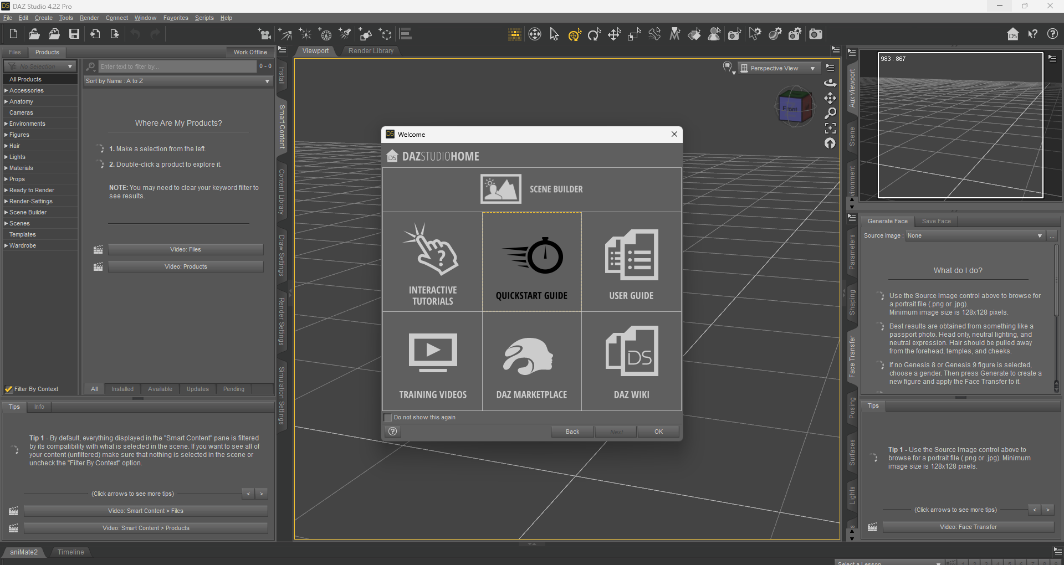

Welp, gotta go to my one and only ever lecture for this module, if I can find the room, that is…..

# 

# **Day 3 - Wednesday 10/01/2024**

Today I did all of the tutorials for DAZ studio, It really isn’t too complex to make basic things. There were a lot of official video tutorials too, so that only made it more accessible to pick up and use. I mostly focused on the pose manager and the face transfer tool. The face transfer tool is the main reason why I’m using this software, as It takes an image input and tries to place a face from that image onto a 3d model.

Luckily, (and quite funnily) my friend Daniel L volunteered to let me digitize his face for a laugh. Using the reference image, below, I produced the render below: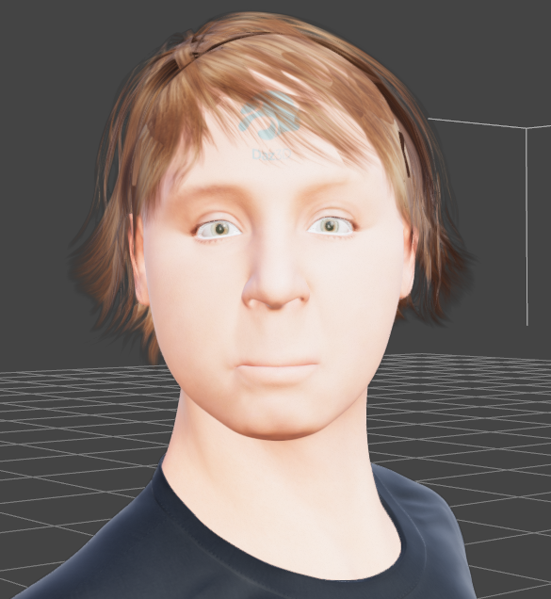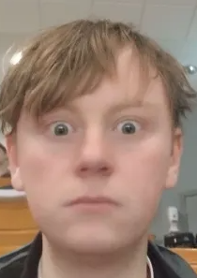

The facial structure itself was generated via the software, but I had to place the hair myself. It seems that I’ll have to include a hair description in the prompt for Stable Diffusion’s Img2Img to get it to draw hair over the model, which may be a later problem I have to deal with.

This is the current look of the editor. The slides make it easy to meddle with the positions of certain parts of the face (e.g nose height, distance between eyes), and certain properties of those parts (e.g smile in lips, open eyes). From what I can tell, the full body poser or scene creator doesn't look useful for me. 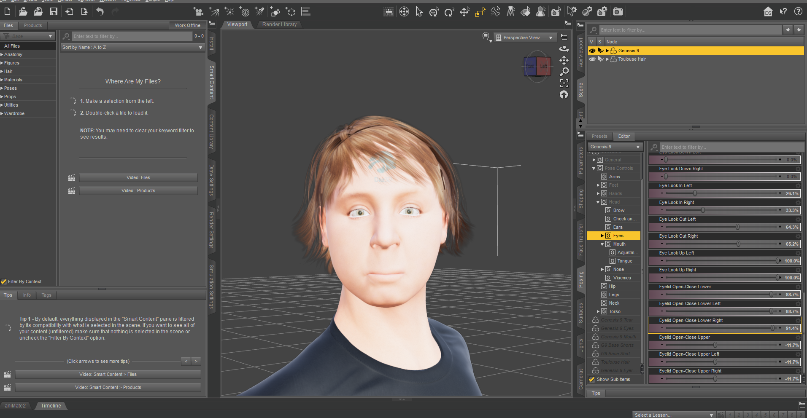

Tomorrow, I’ll work around the camera, and think about how I’ll programmatically render the model into a usable form.

# 

# **Day 4 - Thursday 11/01/2024**

As promised, I have messed around with the camera and rendering functions of DAZ3D. Making and angling cameras wasn’t a problem, they can be optionally controlled via numerical sliders, so that’s most likely how I’ll be controlling them. As for rendering, It only requires a file directory, which is easy to create programmatically if necessary.

Overall, DAZ3D looks pretty accessible to be scripted compared to the competition, which is great news.

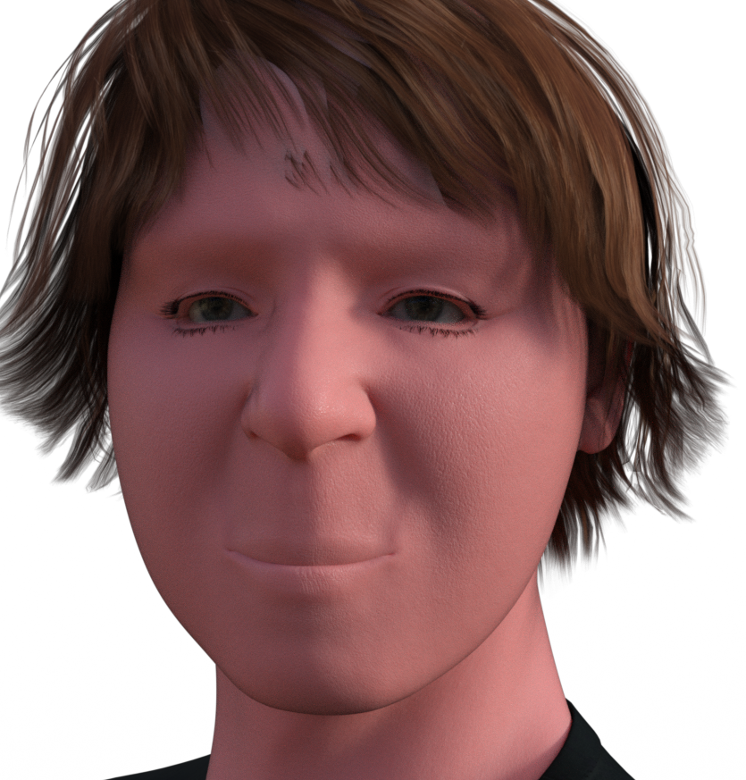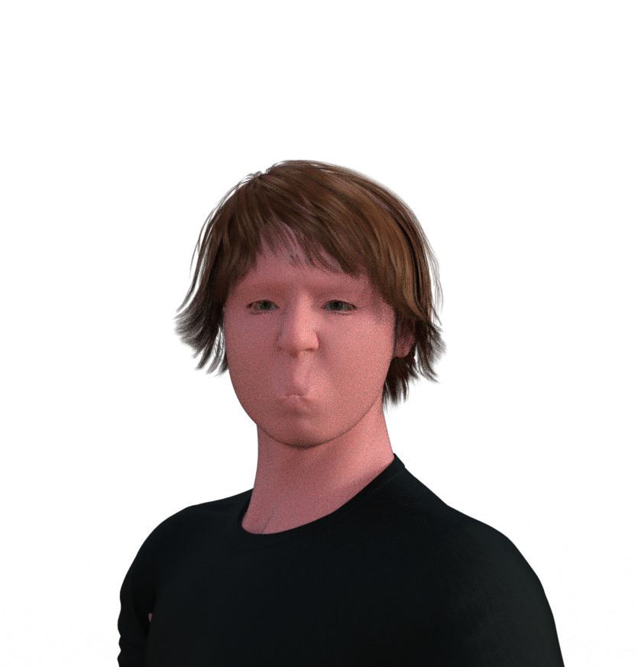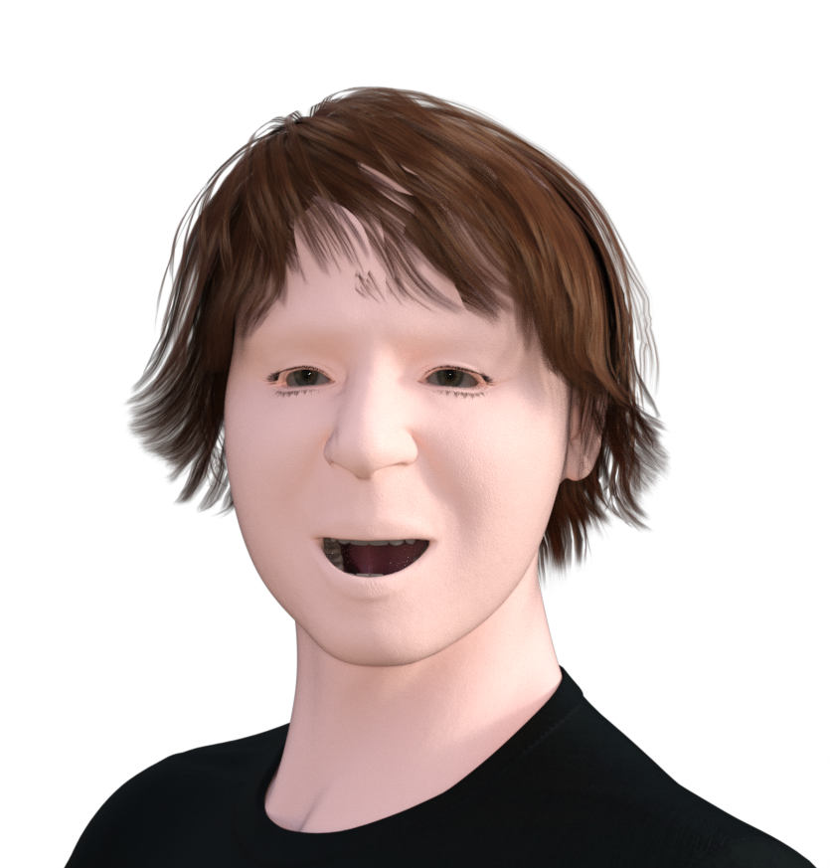

I think that these basic faces should give Stable Diffusion a good template to draw over. Currently, I’m thinking of a shot similar to the center or rightmost image, with the face in the center, and a bit of space around the head to truly show the theme of the certain model adaptation I will be using.

Next, I’ll work on playing around with UI.Vision.

# **Day 8 - Monday 15/01/2024**

Today I installed UI.Vision and began to work my way through the basic tutorials. I’m loving the feel of the software, I didn’t expect it to be making a simple sequence of events rather than just manually coding a macro from the ground up, but I’m not complaining!

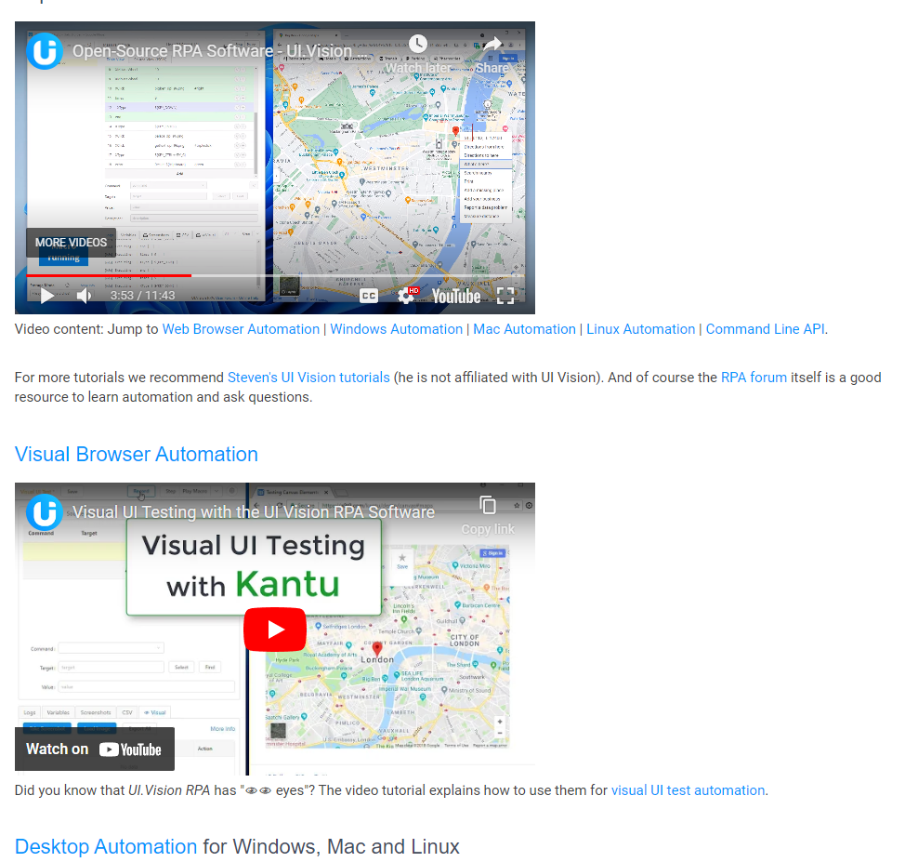

From my initial thoughts of UI.Vision, it looks like a great fit for my project. It can be used along scripting languages to run and manipulate the macro, which will be useful for me. It can also interface via an api, and can be used to create web-based macros if I ever feel the need to make one.

# **Day 9 - Tuesday 16/01/2024**

Today, I completed the last two more specific tutorials for UI.Vision. Afterwards, I made a test program, using the skills that I’d learned. It opens the calculator app from my taskbar, calculates a sum, logs the output, then navigates to Notepad via the Start Menu and types “Hello World!!!” onto the window.

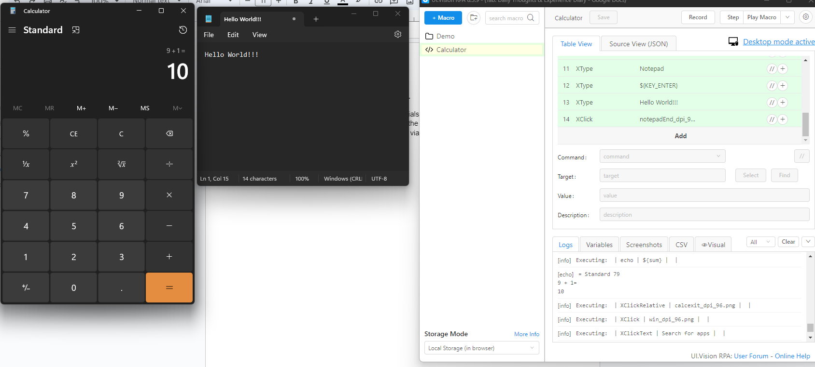

I mostly used the XClick, XClickSpecific, XClickText and XType functions to manipulate the inputs.

To scrape the output, I used OCRExtract and echo functions.

I specifically like XClickSpecific, as it allows me to make sure that the selected area is correct, by giving more surrounding data to narrow the search down.

For Example:

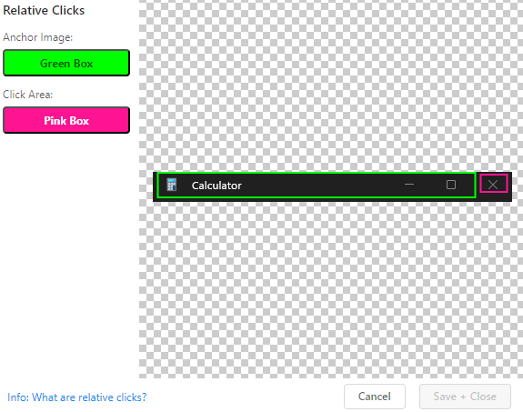

I used this menu to divide my image into Anchor areas and Click Areas, the anchor functioning to ensure that the click area is 100% at the intended position.

During this, I was chatting with Caleb again, and proceeded to shamelessly shill the software I’ve hardly just begun to use. B>)

[macrotest.mp4](https://drive.google.com/file/d/1HtYumNq0N98EUh8Eokr4YAuMhfoWz4EP/view?usp=sharing)

# **Day 10 - Wednesday 17/01/2024**

Today I had a meeting with Aidan and John in QLab for an hour. We discussed both of our projects and got some guidance going forward.

Next up for me:

* Using UIVision to make a macro that will modify Daz3d face settings based on an input
* UIVison will take a screenshot
* This will repeat until a large library of faces have been taken

This taxonomy of faces will be needed going forward, to be passed to StableDiffusion in the next steps.

Currently, my plan is to make some sort of controller program, which will run the different macros which will manipulate the settings of the face, and will also iterate through all of the types of faces.

Currently, I will limit this program to only generate faces in the angles N,E,S,W and straight on.

I will limit my facial expressions to blank and happy.

My desired output will be a folder of .png images of blank and happy faces in each of the cardinal angles, and looking straight on.

Below I have included some examples of what this should look like. (Straight on, above, below)

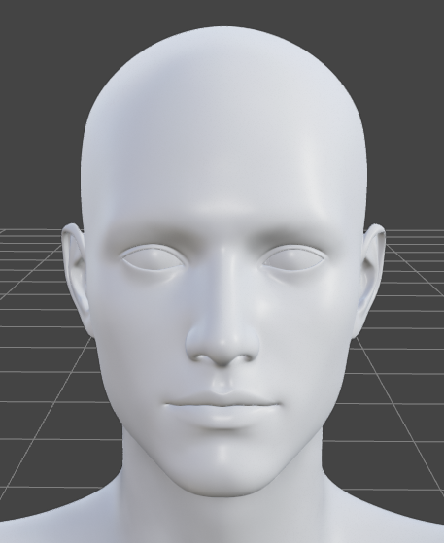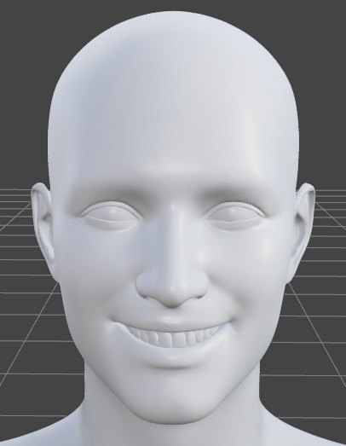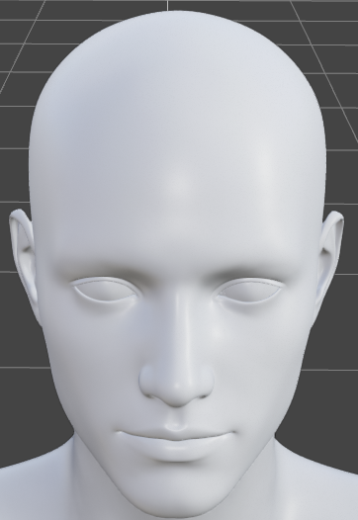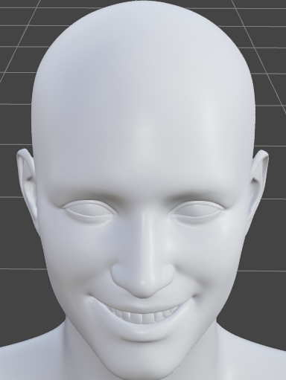

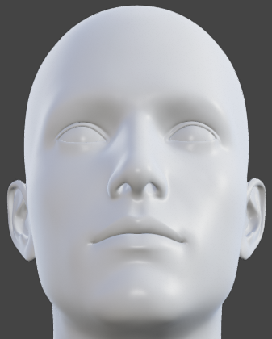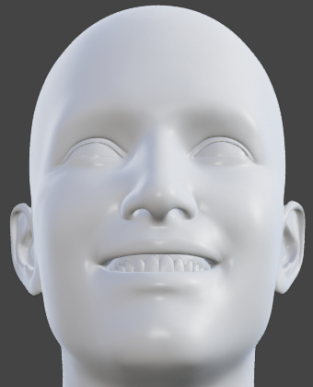

There are controls in the “pose” section of DAZ3D which handle smiling faces, which will be useful.

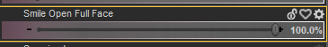

Thus, I only have one slider to change for a handful of preset emotions, and phonemes.

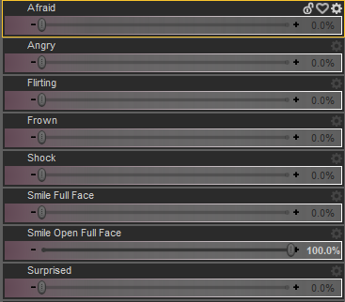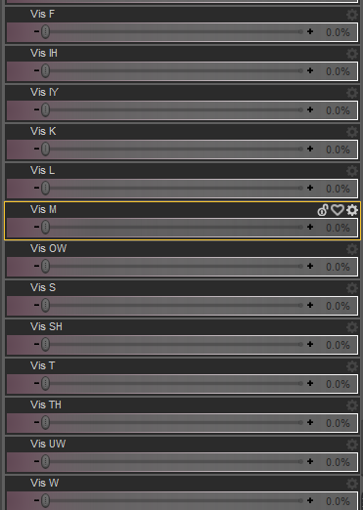

So, I will currently need to make macros for:

* Opening DAZ3D & loading the model into the basic position
* Taking a screenshot of the screen
* Opening the pose menu and selecting face poses
* Setting an emotion (e.g smile open full face)
* Unsetting the certain emotion
* Moving the camera N, E, S, W

I have also found a website which bulk crops images, this can be used to take the faces from the full screenshots of the entire program.

<https://bulkimagecrop.com/>

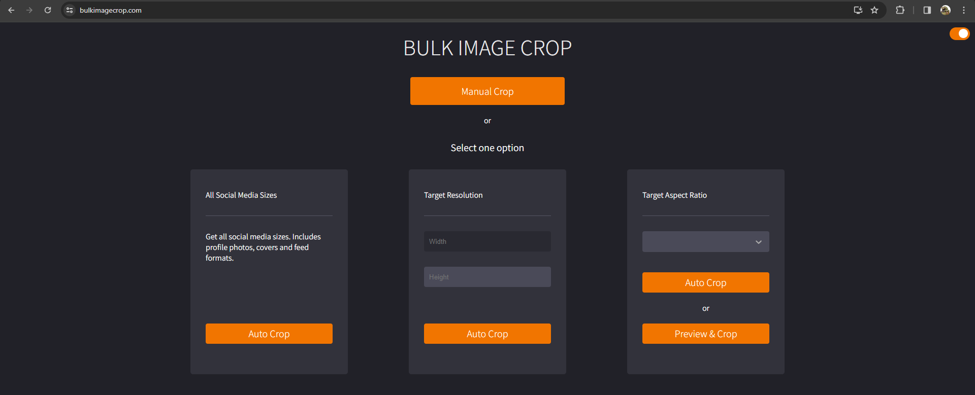

I have also made a basic save of a blank model staring forward into the camera, it should work well as a starting point for the macros.

# **Day 12 - Friday 19/01/2024**

Today, I began my work on the macros controlling DAZ3D.

The first macro will open DAZ3D, load the blank model and open the “Poses” tab.

I made this below, as shown:

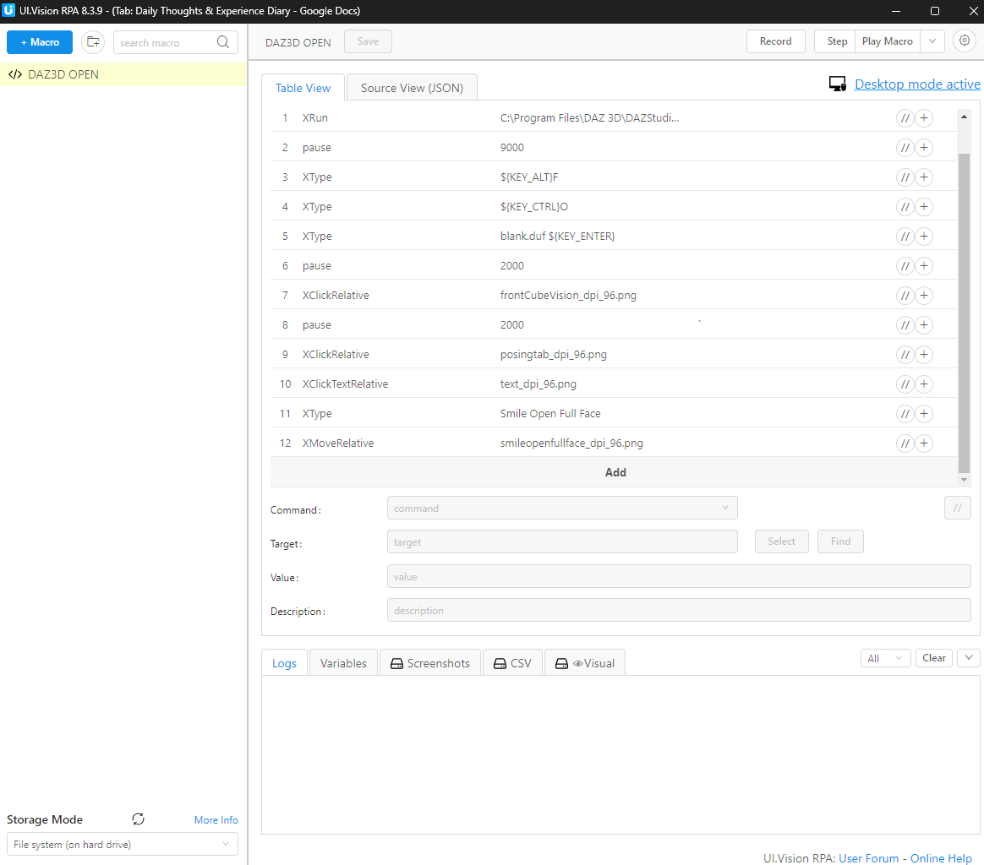

A problem is that this macro can not be rerun right after closing, as DAZ3D takes a few seconds to close fully, but this should only need to run once, so It’s not so bad.

This will run first before all the rest of the macros, and will prepare the desktop for the next macros to run.

# **Day 15 - Monday 22/01/2024**

Today, I worked on the screenshot functionality of UI.Vision.

Looking back on it, I wasn’t very smart with how I tackled this problem!

To define a step in the macro, I have to fill these fields, most of the time, only the first 2 must be filled.

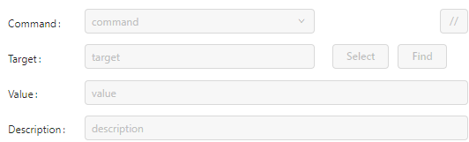

The command to screenshot is captureDesktopScreenshot, but whatever I put as the target, an error occurred. I continued to brute force the field with file names, variables and null values, but nothing worked.

So obviously the answer was to go to google and look for a solution, but I didn’t find very much documentation for UI.Vision.

But eventually, I found a link to the documentation for the command, and found that I had to put in a file directory and file name for the screenshot to be saved to, which is pretty nice actually because I can create an output folder, which I did.

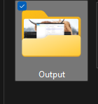

So the screenshotting function works well, and alongside that group cropping webapp, I will be able to get the 512x512px images of the faces to let the model train on.

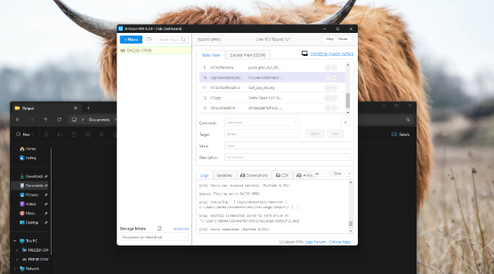

# **Day 16 - Tuesday 23/01/2024**

Today, I added the screenshot functionality to the initial macro.

This macro:

* Opens DAZ3D
* Loads the blank model
* Takes a screenshot of the blank model with no emotions
* Opens the pose menu

The next macros:

* Set an emotion

Or:

* Set an angle

Or:

* Screenshot

Or:

* Undo emotion

Or:

* Undo angle

These will be put together programmatically to achieve mixes of settings e.g:

1. (Initialisation macro runs if has not already)
2. Set angle South
3. Set emotion ‘Smile Open Full Face’
4. Screenshot
5. Emotion North
6. Undo emotion ‘Smile Open Full Face’

As seen above, the ‘set angle’ macros can be undone by setting the angle to be the opposite direction, but the ‘undo emotion’ macros will need to be independent from the ‘set emotion’ macros.

[macroinit](https://drive.google.com/file/d/1Hj2miZZcKDubhGZLFQ4qESzK6uDZg16R/view?usp=sharing)

I have also put together the macro which sets the Smile Open Full Face emotion.

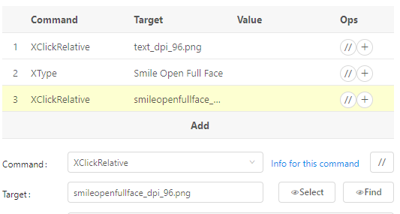

It selects the option, finds the control of the slider and moves it to the right.

In the next days, I will begin to build the other macros which manipulate the sliders.

Finally, I will have to create a program which manipulates the order of running of these macros.

# **Day 17 - Wednesday 24/01/2024**

Today I had another meeting with Aidan and John Bustard. We discussed the macros to be made, and what I would be doing with the images of the posed faces once I collected them.

What I have taken from this:

* Use Camera objects with set positions instead of moving the preset camera N,S,E,W etc. Swap between them.
* In the init macro, use the AI face from image tool
* Create a Background behind the image with a static colour using the Scene Editor (I’ll make a greenscreen)
* Create a number of lights which will be made visible or invisible by the macro (only one on at once to create different lighting angles)

I have also been told to begin my guide now, which I will start tomorrow.

I’m surprised that the deadline has snuck up on me, so I’ll be sure to focus on it until it’s done and handed up.

After reading a bit on the guidance, to make the guide I must:

1. Make the full script
2. Get Komodo Edit installed and working
3. Use Komodo Edit to turn the script from a .docx file into HTML
4. Make sure the HTML is correct

The guide is a little daunting, but I should be able to complete it in time.

# **Day 18 - Thursday 25/01/2024**

[Guide Script](https://docs.google.com/document/d/1lIfB1irSt2Qk7d4A6gj0KvjyvvjGwMuScRgmshyzmJE/edit?usp=sharing)

Today I began typing the Script for my Guide.

My guide will be on UI.Vision and its use with other software (like DAZ3D), just like my coursework.

I have created the loose plan for the guide script, making the table of contents.

I will first show how to install and set up UI.Vision, then will teach some basic commands for UI.Vision, then I will walk through an amount of examples which show how to make simple, good macros. I will then quickly walk through more advanced commands with flow control, then will go on to use UI.Vision with DAZ3D to show the macro I am currently producing. I will also have to include install instructions for DAZ3D and a brief overview of controls.

I have also typed up a quick preface for the guide. I would like to include some sort of glossary page in the HTML, but I will cut this out if I have to.

# **Day 21 - Sunday 28/01/2024**

Over the last few days, I have been continuing to slowly chip away at the guide script, but I have been mostly making notes for my other modules.

I am 11 pages into the guide, having mostly worked on the installation and set-up of UI.Vision, but have also worked on teaching the basics of UI.Vision, showing off some simple commands and how to write lines of code.

I’m finding it quite hard to write about building up the guide script for this entry, I don’t have much to say.

I’ve been using mostly screenshots and captions to show the procedures I am working with. I think it’s the best way to make the guide. I have heard that to upload my HTML, I may need to include a .zip file of all the images, so I hope that Komodo can manage images easily, and that it won’t get annoying later on.

I will be fully focusing on the guide from now on, until it’s done.

# **Day 22 - Monday 29/01/2024**

I’ve been suddenly very sick for all of today, so I’ve been staying at the house and have been taking it slow.

It’s really annoying that I’m sick at the worst possible time, but I can apply for exceptional circumstances if I really need to, but I think I’ll be fine.

I’ve managed to get a lot of typing done, though, and am now 17 pages into the guide script. I have completed the section about teaching UI.Vision, and am now onto the worked examples.

I expect to get through the worked examples quickly, though.

Also, I’ll need to convert my Script into a .docx file for Komodo, which can thankfully be done easily with google docs.

# **Day 23 - Tuesday 30/01/2024**

Today I called Caleb to chat with him about the guide, to make sure I’ve been doing it right.

We’re both doing a quite similar guide script, both focused on teaching how to use a certain software to manage the desktop.

I think I should take out the interaction of UI.Vision and DAZ3D from my guide script as I don’t think it really belongs, as other step-by-step examples use software built into Windows. I don’t think that people will go through the steps to install and learn how to control DAZ3D, just to use it for one small worked example macro. Caleb agrees too.

I have nearly completed my guide script, only having the very last section left to complete.

# **Day 24 - Wednesday 31/01/2024**

Today I had another meeting with John and Aidan. This time I had it online, I wouldn’t want to give anyone else my flu!

I’ve been given a couple cool resources to look at:

* If I have trouble with Komodo Edit, I could use Cyotek Webcopy
* If I want to host the HTML afterwards, I could use Github Pages
* VRoidHub may be useful to find a couple hair models for use in creating the dataset. I could take the hair model and place it on the body model before running the macro to create a dataset with the hair.

Also, my Guide Script seems to be good, so I will begin to bring it into Komodo Edit.

I’m looking forward to getting this assignment over and done with, so I can finally focus on the fun stuff again.

Also, as per John’s request, here are some reasons as to why I have chosen to make my Guide on the basics of making UI.Vision Desktop Macros:

* The documentation of UI.Vision is very minimalistic, and can be confusing. Most Commands only have a few sentences of detail. In my guide, I give more detail to each of the commands I talk about.
* Large concepts like Anchor Images and Flow Control are very vaguely explained, and all hinge on one short, old video of low quality. I explain Anchor Images and Flow Control commands in more detail in my guide.
* The documentation has nearly no worked examples. My guide is based around step-by-step worked examples.
* I found it initially confusing to find and activate the Desktop functionality of UI.Vision, as it is tucked away in the open beta settings. I walk through this setup process alongside recommended settings and storage options in my guide.

Hopefully these traits will make my guide a useful tool to be used alongside UI.Vision’s documentation to gain a clearer understanding of the software and its use.

# **Day 25 - Thursday 01/02/2024**

Today, I completed the last section of the script for the Guide.

I then began to learn and use Komodo Edit to make the html.

I didn’t like using Komodo very much, as it has nearly no functions aside from being somewhere to type.

So, I used <https://wordtohtml.net/> as an online editor, and found it a lot better.

It also let me copy everything from my .docx file into the html.

After doing this, the html looked okay, but looked like something from an ‘80’s blog page.

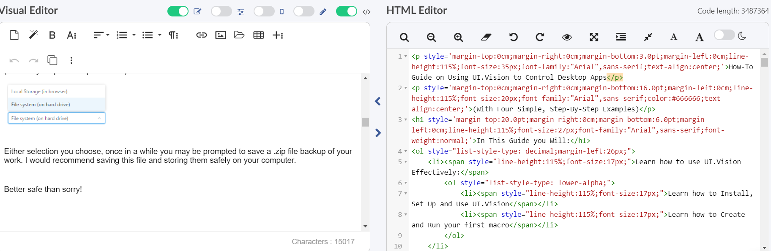

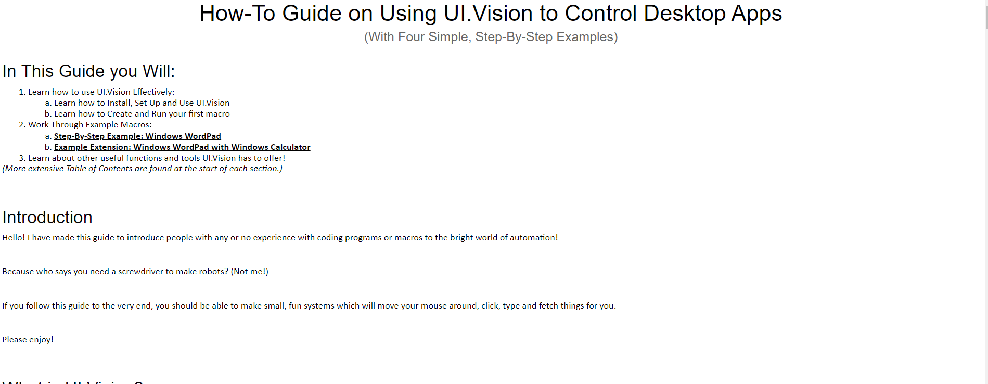

When looking for templates and cooler ways to design html, I found out that Word has a function to convert your .docx file into a fully put together static .html site!

I think it looks a lot better.

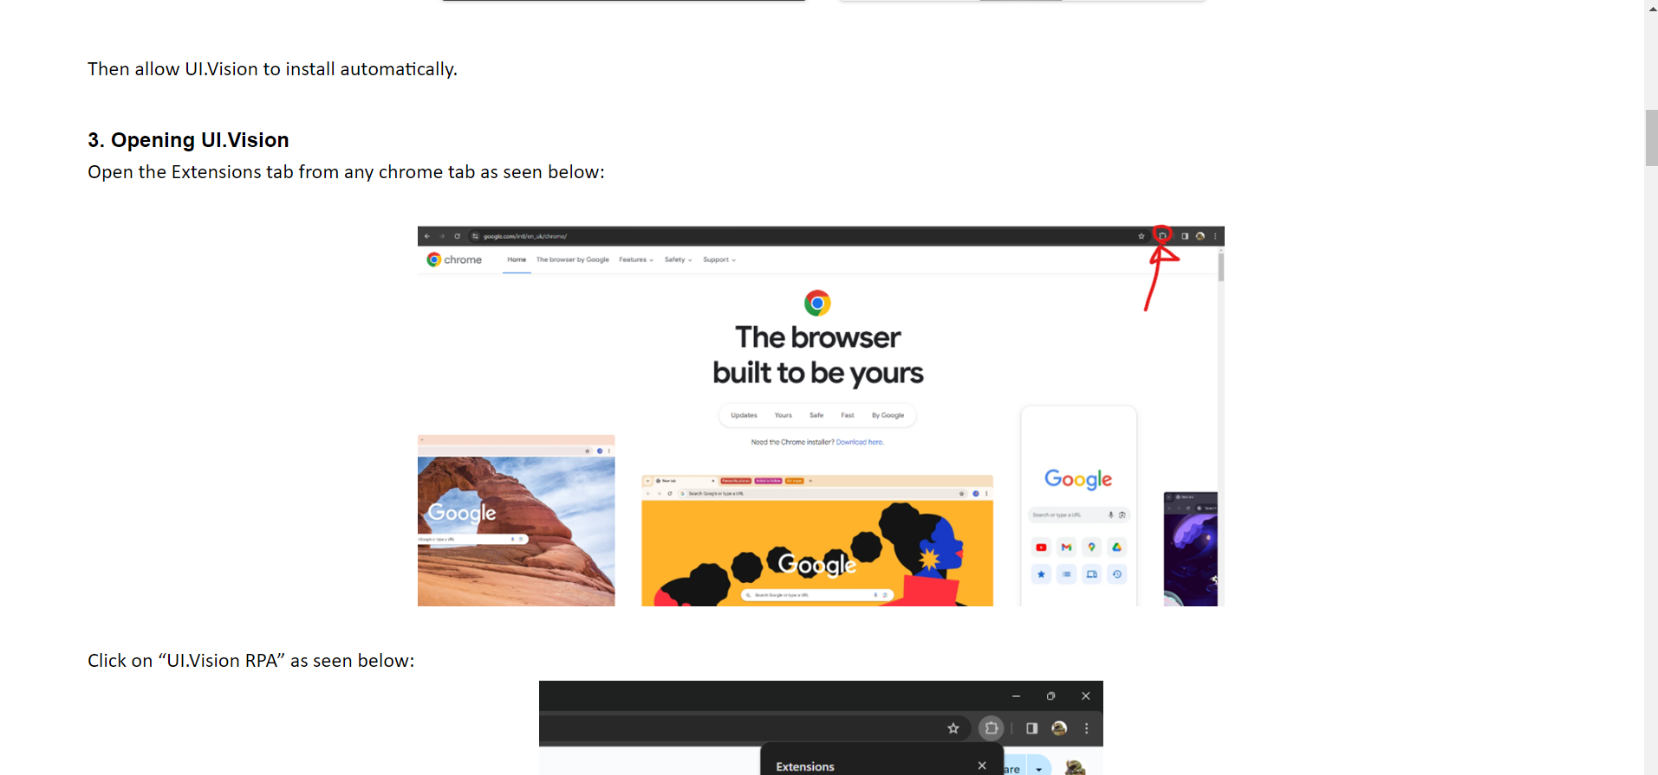

# **Day 26 - Friday 02/02/2024**

Today, I only did some finishing touches.

With Word, I could easily make links between my HTML pages, so I could split my guide into 4 parts.

And with help from Caleb, I also threw together a bit of CSS to give the page a padding area, to make the text more central.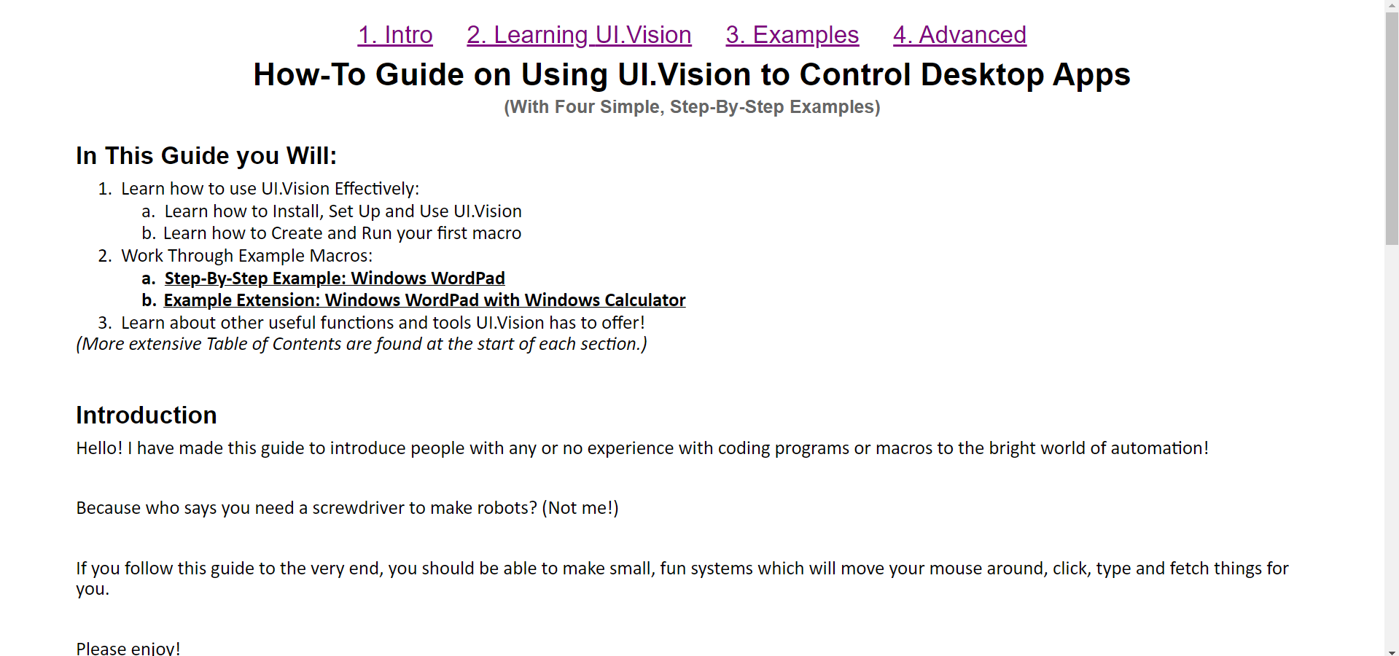

Then I sent it off!

# **Day 29 - Monday 05/02/2024**

Today, I finally(!) continued with the macro, updating the initialisation macro to use an uploaded face as a template for DAZ3D to generate onto.

The macros together can:

1. Open DAZ3D and load an empty file: (as before)

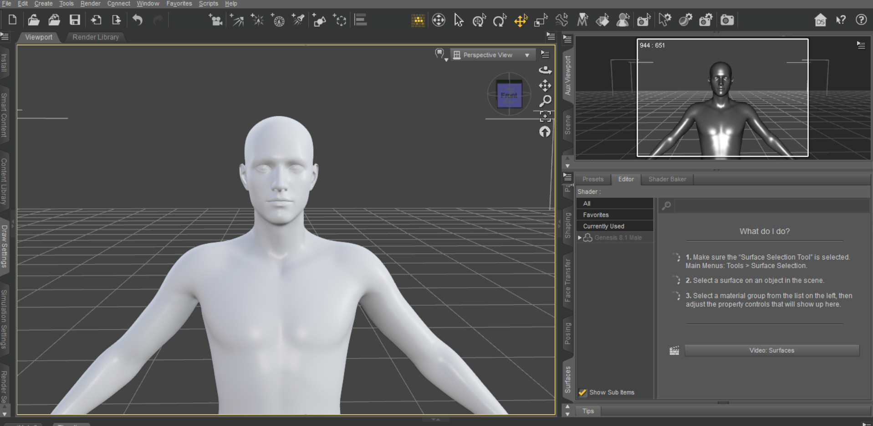

1. Use the generator tool to generate a face (by AI) based off an input image:

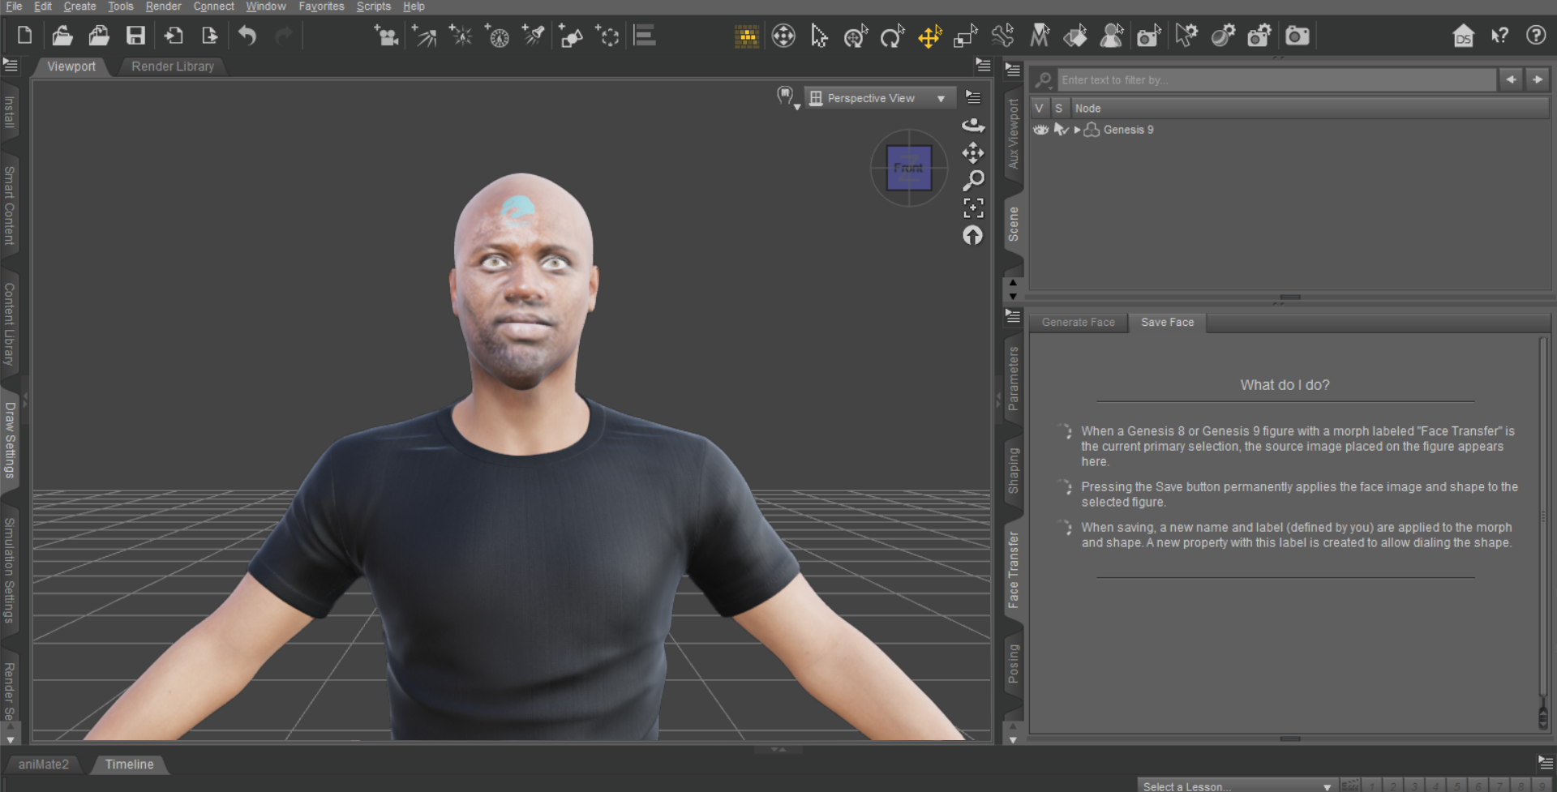

1. Use the sliders to turn ‘on’ or ‘off’ an emotion

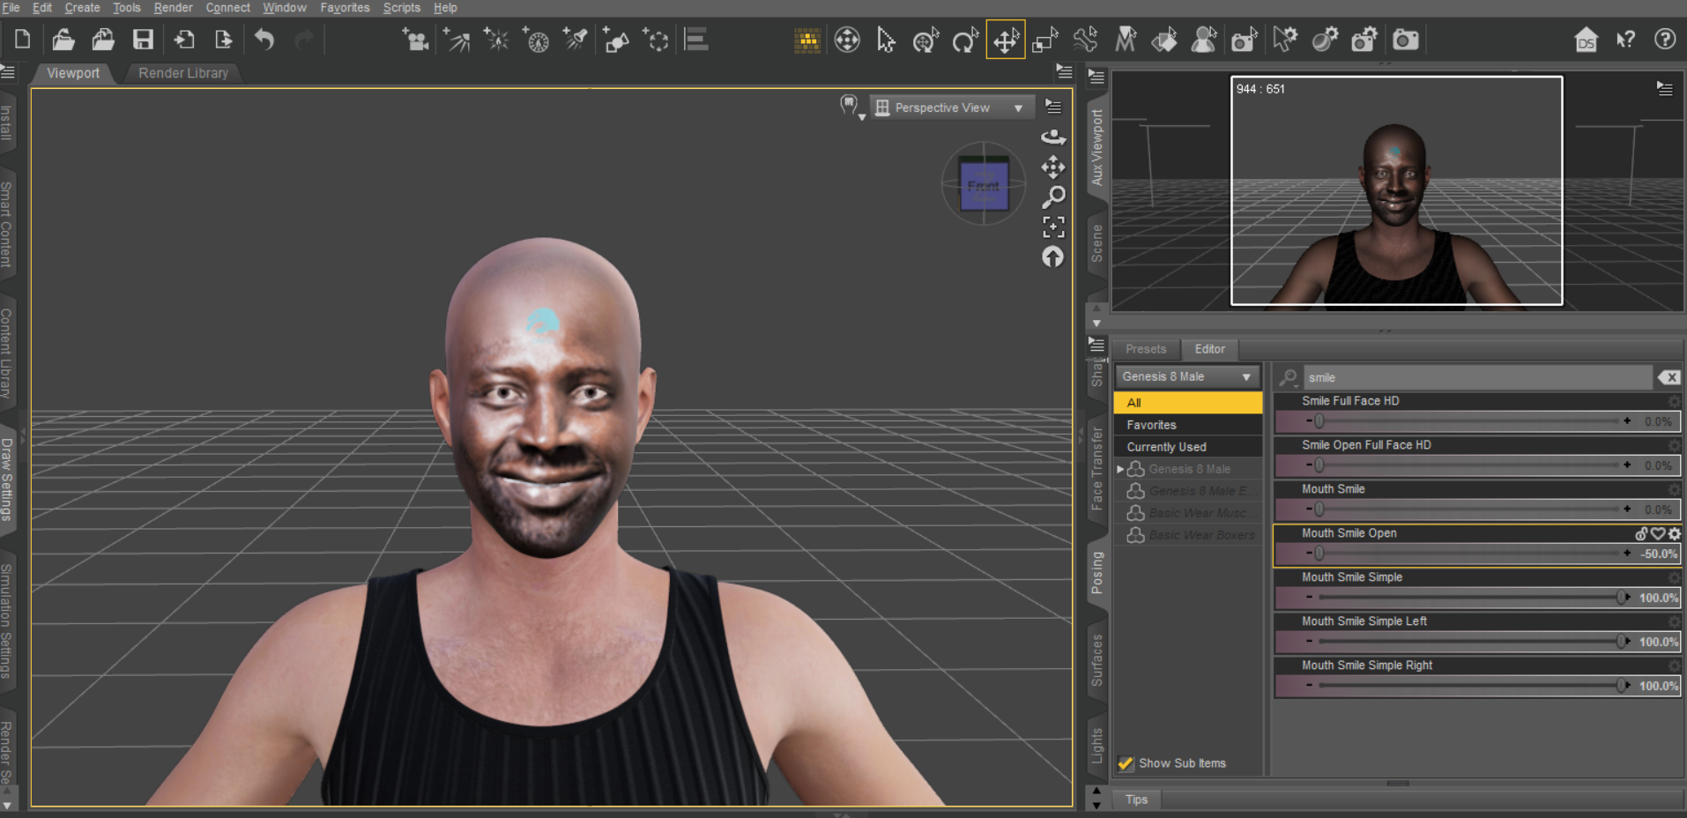

These macros are currently separated into different smaller pieces, which will be mixed and matched by a controller program (also in UI.Vision):

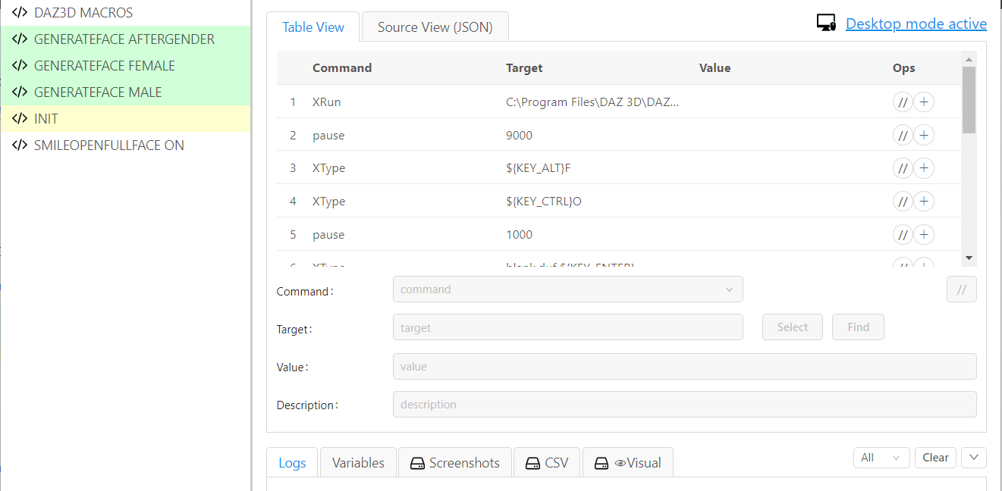

I also checked around VRoidHub to find a set of suitable hair models for the characters, they’re a bit stylized but could be useful for generating a couple more varied datasets.

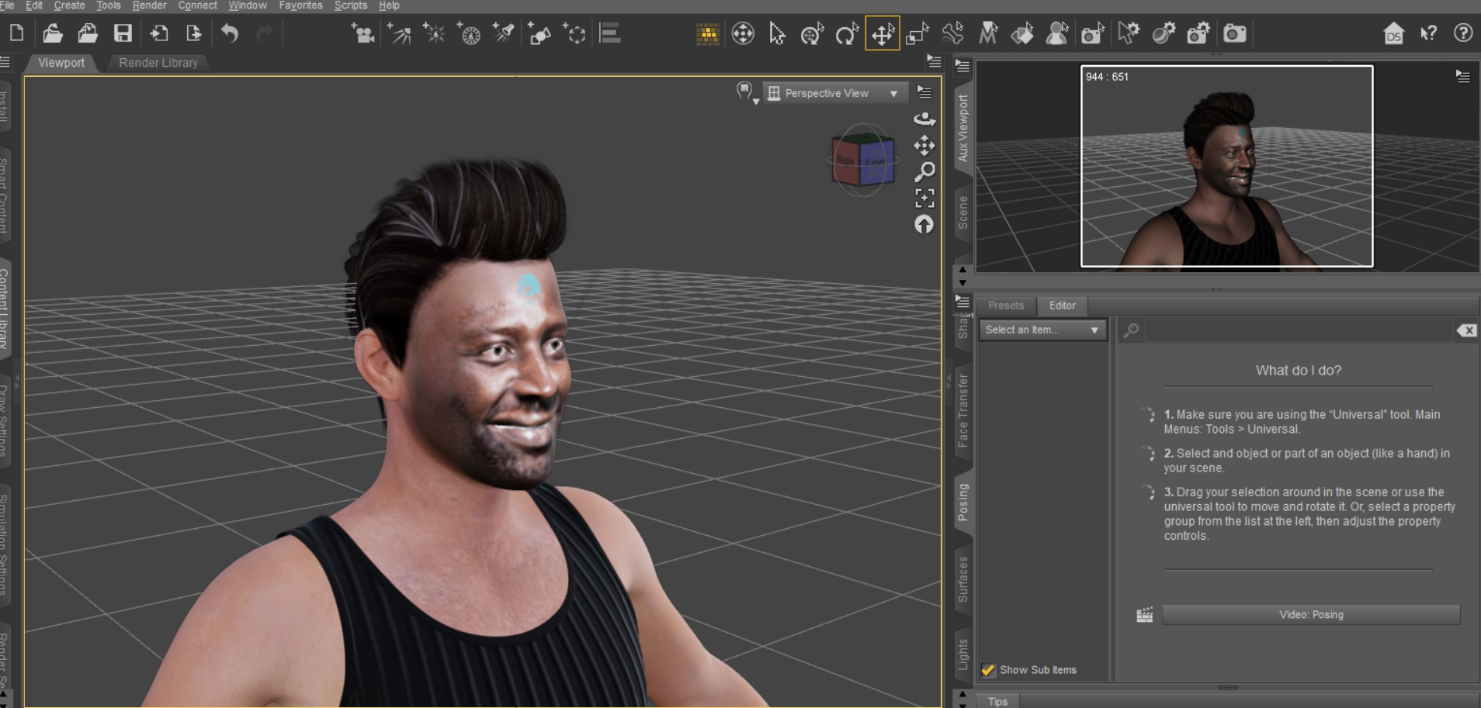

These shouldn’t be interacted with by the macro, so I should be able to just put one of them on, then run the macro, then change the hairstyle!

With every little extra variable I add, the dataset I will create will get bigger and bigger, with not too much added effort. It has a lot of scalability, which is a great goal.

# **Day 30 - Tuesday 06/02/2024**

Today, I installed cameras for N, S, E, W on DAZ3D to be cycled between instead of panning the camera.

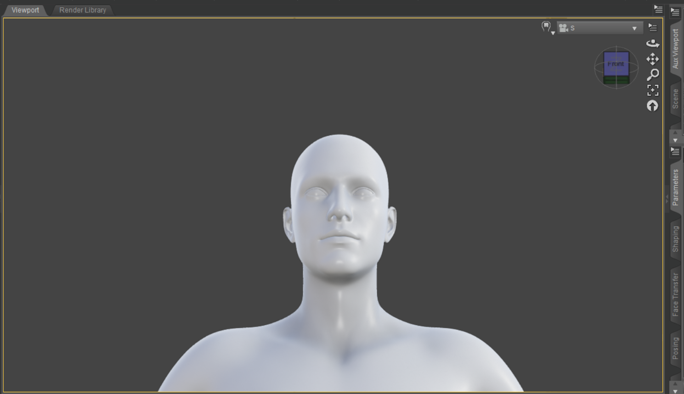

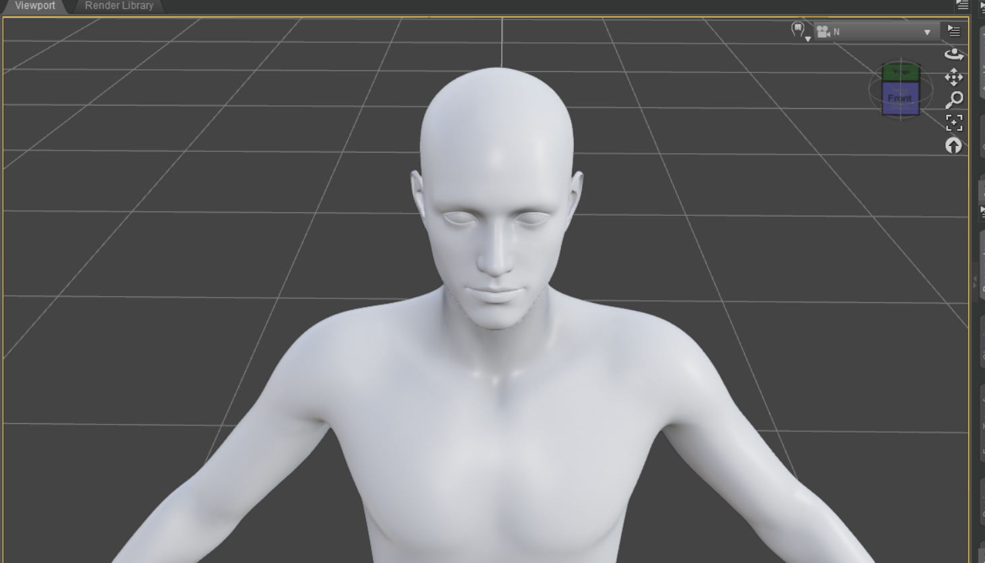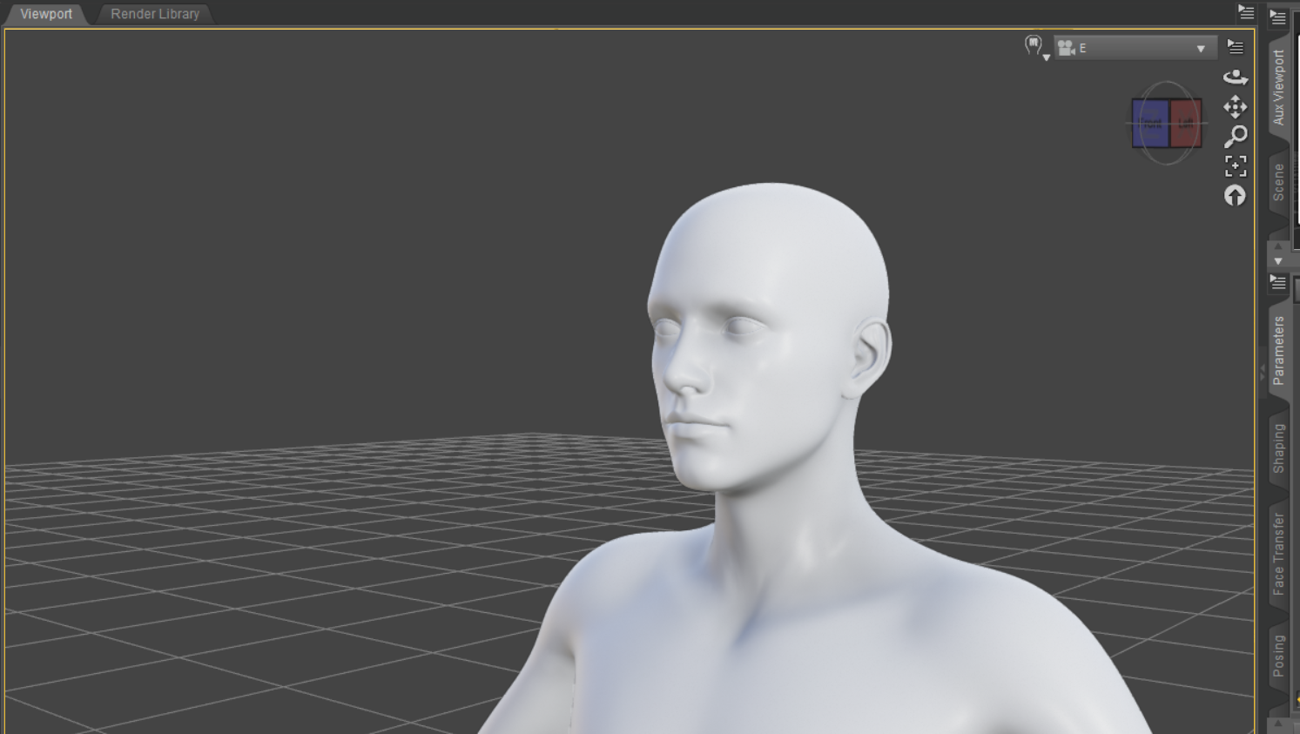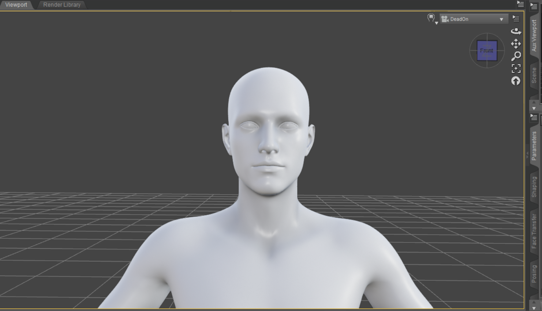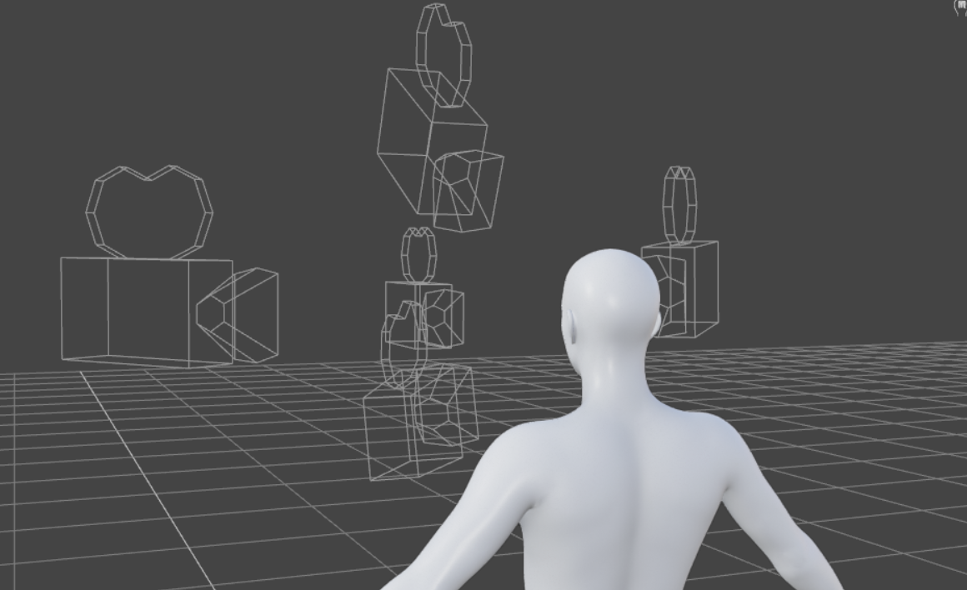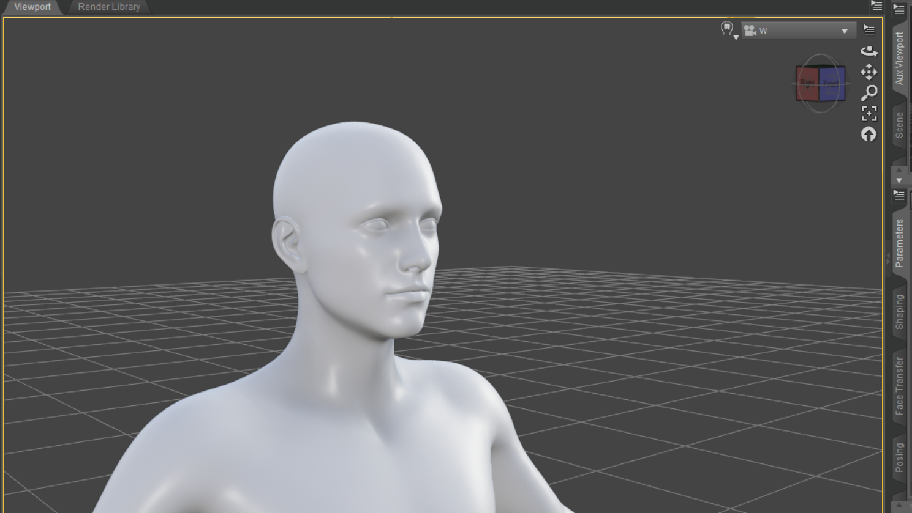

I then created spot lights, which can be turned on and off programmatically.

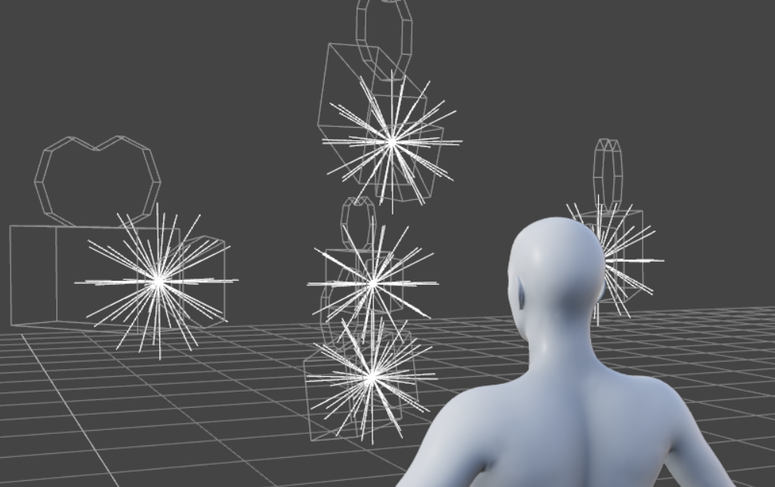

I have set a static greenscreen background to the scene, just to remove DAZ3D’s default grid layout, which might interfere with the output.

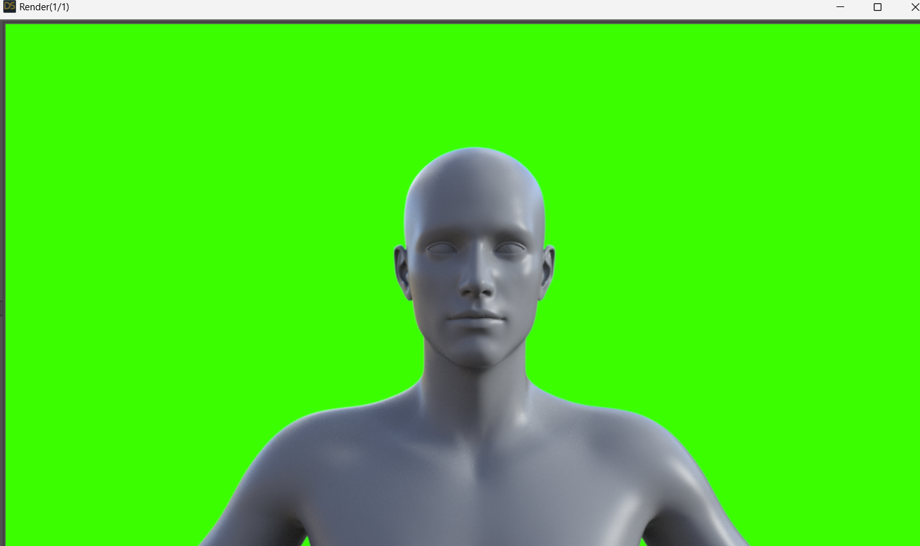

# **Day 31 - Wednesday 07/02/2024**

Today I continued on building my smaller macro functions.

Strangely, a few of the images I used for the XClick and XClickRelative had to be remade to function as intended, I hope this problem dosen’t return.

I ended up having to redo every image past the halfway point of the init macro and every macro afterwards, which took an annoying amount of my time.

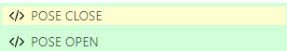

But afterwards, I designed and implemented two macros which open and set up the posing menu, and one which resets the menu back to its starting position.

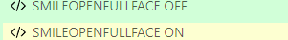

I also finished my macro which applies the smile emotion to the model, and made a counterpart which undoes it and returns everything to a base state.

Each function will begin and end in this base state (where the renders/screenshots will happen), which will make it much easier to link up together, as I can just put the commands in a big for loop or something. I could consider using a big csv file to store the commands, but that would be pretty inefficient and have low scalability. Given that my dataset will hinge on scalability to continue to improve, that wouldn’t be the best.

As for stringing the parts together, I actually think UI.Vision might be able to do the job, but I’ll need to put in more research to be sure.

# **Day 32 - Thursday 08/02/2024**

Today I have been pulling my hair out over a bad logical problem.

I made the rendering macro, which will activate the render, and would then need to take a screenshot and save it to a folder. The problem for me is that UI.Vision lacks any way to make screenshots save with an auto generated file name, so they just keep overwriting each other.

I have tried using CSV files, each variable holding a number from 1 to 100, but there is no way to find out the index needed, as each time the Render subroutine runs, it will not know how many times it has run before!

I also can’t just use looping code, because I need to run other subroutines before running the Render subroutine again, and then all variables will have been wiped. I’ll just have to sleep on this.

In the meantime, I made macros for changing the camera angles, not the hardest thing in the world but it’s something for today at least.

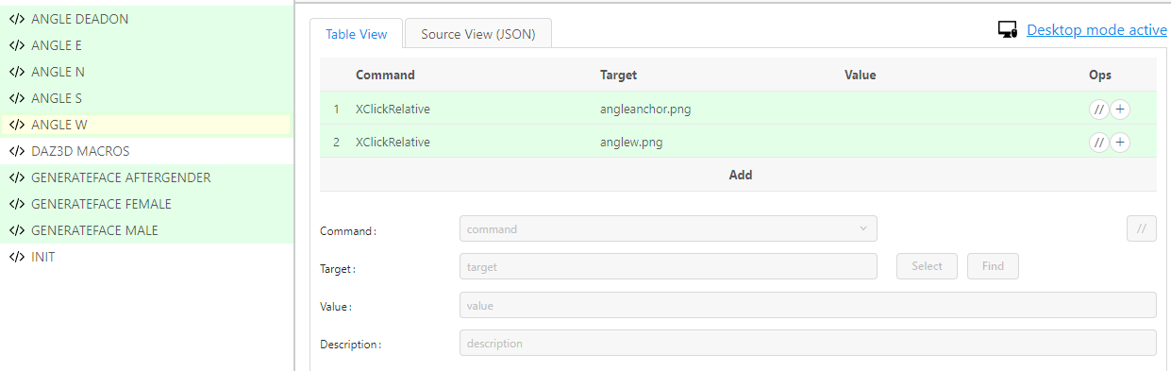

I have a big test on DBs on Monday, so I’ll be focusing on that this weekend.

# **Day 36 - Monday 12/02/2024**

Today was the token annoying troubleshooting day.

I was about to start making my light controlling macros, the very last ones to make, when I was told that I could save no more macros!

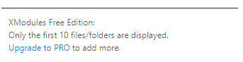

And of course it’s a million pounds, too.

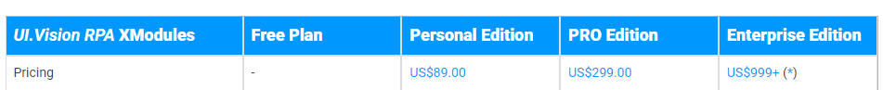

Very very luckily, I can still use the cloud saving past 10 macros, it’s only limited when I save it onto my local computer.

Phew!

When moving my macros over to the cloud storage instead of the hard disk, I made a classic blunder. When exporting the images I needed to move over, I accidentally moved every single image, including the ones used in the built in tutorials.

I had to delete all the images manually one by one, each taking about 5 seconds to do. There was about two hundred of them!!

So! I make a macro in UI.Vision which controls UI.Vision, deleting the images I hovered over, so I can keep the useful ones. It probably wasn’t faster than just doing it myself, but it was a fun opportunity to use my macros as a personal tool. (I could also just sit back and let the computer do most of the mindless labour for me.)

I managed to catch a small recording of it while it worked:

[metamacro.mp4](https://drive.google.com/file/d/1MYPYQ1ty6wrW7lcV5DHFfheQYGxFChRX/view?usp=sharing)

Also, I’ve found a solution to my tricky bug from yesterday. UI.Vision itself may be a candidate for a good program to string together the macro subroutines, and if I do so, I’ll be able to simply have an incrementing variable which ticks up every time a screenshot occurs.

So, I’ll move the screenshot procedure from the RENDER macro, and instead move it to the main controller macro. The screenshot function allows for variables to be placed into the file path of the screenshot, so I will be able to simply number them, getting around the problem with identical file names causing files to overwrite each other. It’s a shame that this violates my ‘return to base state’ strategy, so It’ll take a bit of effort to work, but it’s the only solution I’ve come up with. I’ll make sure to ask John Bustard next Wednesday, in case he has any better ideas.

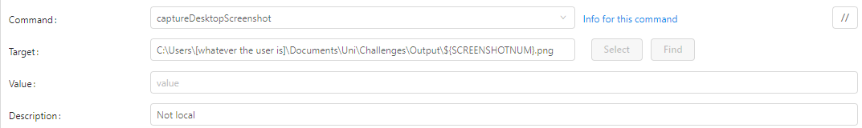

The procedure for the screenshots will look something like this.

I have also now marked everywhere in the macro where static filepaths are used, which will have to be changed manually to suit the computer the macro will run on. I will most likely use the CSB computers in QLAB, so this will help me in the long run.

# **Day 37 - Tuesday 13/02/2024**

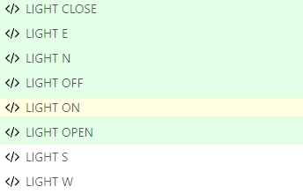

I made these macros today. They control which point lights are turned off and on.

Light open opens the light menu

Light n/s/e/w selects the wanted light

Light on/off turn the illumination of the light on or off

Light close closes the light menu, returning to the base state

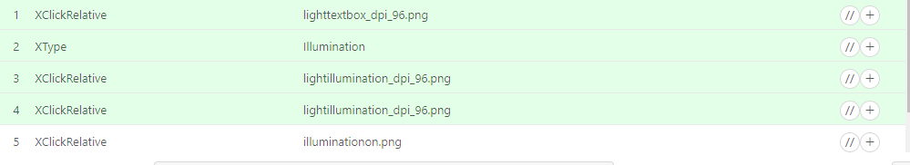

Each macro is about 5 procedures long, mostly clicking and typing.

I would be able to make my code so much more optimised if I had stuff like arguments into my macro subroutines, like a method in traditional code. I would be able to get rid of most of the many subroutines, but my code still has no repetition of lines of code, so it’s as good as I can make it for now, at my current skill level.

But just look at how many there are!

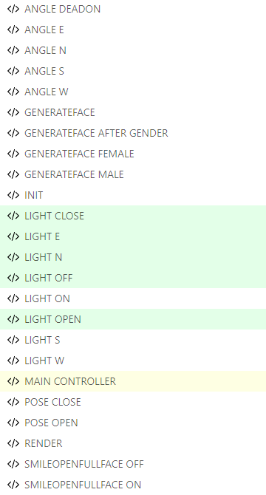

But anyways, with these, I believe I have enough macros to create a great starting dataset!

Now just to tie them together…

I can actually use UI.Vision to do this! The Run command can apparently run other macros I’ve made, so UI.Vision is an option.

But, I really dislike how unconventional UI.Vision is. To me,even simple loops and if statements become an annoyance. I’ll try to make it in UI.Vision, but if it’s too much of a hassle, I’ll just throw together a python script to do it instead.

# **Day 38 - Wednesday 14/02/2024**

Well, that was easy.

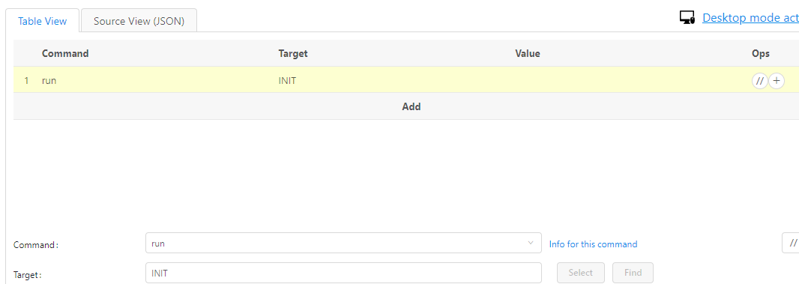

All this researching for/preparing to write a good program to run macros, and UI.Vision does it in two words.

My problem was I was getting ‘run’ and ‘XRun’ mixed together. I thought they were the same thing. ‘XRun’ runs apps, ‘run’ runs other macros.

Welp, working on it now…

Later on…

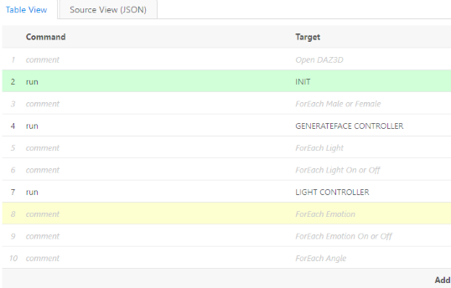

This is my basic idea for the structure of the Controller Macro.

Just building the CONTROLLER macros for each of the groups of subroutines.

Gender -> Lights -> Lights on or off -> Emotion -> Emotion on or off -> Angle -> Render

Building this with scalability in mind, it’s gotta be super robust if this is going to be useful.

# **Day 39 - Thursday 15/02/2024**

Today I kept working on the super macro.

Actually, I’ve split it into 4 smaller super macros, controlled by one super duper macro.

But, my subroutine controllers act like recursive functions and call in themselves, as well as calling the next layer of detail for the dataset.

(e.g for each setting of X, we need to call the next function, Y, then this increases until render. But each function X must also recursively recall itself to set the next setting of X before then moving to the next Y.)

The above is super hard to read, so basically what I’ve made is this:



So:

Each time I run the main:

1. GenerateFace Controller runs once per body type (2 times)
2. Light Controller runs once per time GenerateFaceController is run, and runs Pose Controller for each combination of 5 Lights(3125 times)
3. Pose Controller runs once per time Light Controller is run, and runs Angle Controller for each Pose on or off (2 times)
4. Angle Controller runs once per time Pose Controller is run, and runs Render for each Angle (5 times)

So: 2*3125*2*5 = 62,500 screenshots plus one for the initial blank face, so 62,501.

And this is per single run. I could do it again with a hair model on the body then I would double the number.



Maybe I shouldn’t have gone so wild on the lights…

# **Day 43 - Monday 19/02/2024**

The super macros are coming along well!

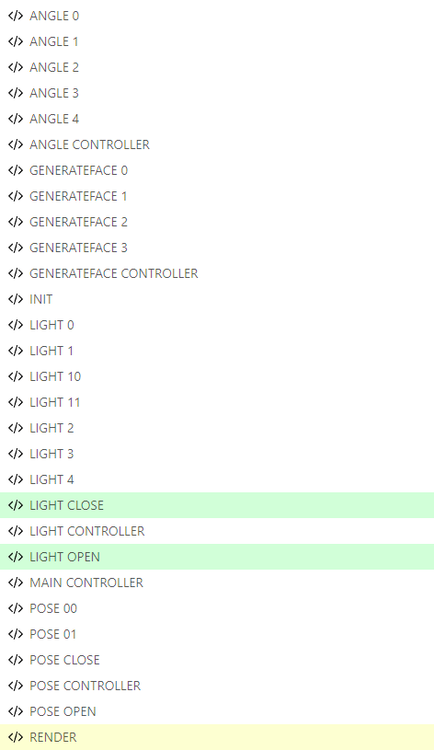

I’ve had to rename all of the macros to numerical values so I can iterate through an accumulating integer variable to call them sequentially.

I’ve scaled back the control of MAIN CONTROLLER, and made each of the [X] CONTROLLERs call each other instead of returning to the MAIN a lot. Saves a bit of time each cycle, which will definitely add up in the long run!

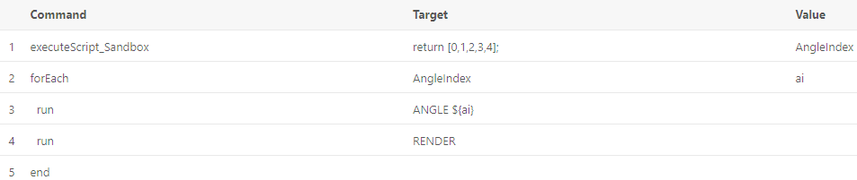

So, looking inside ANGLE CONTROLLER, you can see my newest tool, executeScript_Sandbox!

executeScript_Sandbox is amazing! It allows me to do a block of conventional coding, to easier set and return variables, mostly.

All of my CONTROLLER macros follow this structure:

1. Using executeScript_Sandbox, an array for the suffixes of the titles of the macro subroutines that this super macro will run are found and saved as a variable
2. For each item in the array, run:
   1. A subroutine referenced to by the index of the initial array
   2. The next CONTROLLER (or, if none left, RENDER)

But, my next problem is that RENDER is now very separated from MAIN CONTROLLER, so my original solution to my file name problem won’t work.

I’ll have to fix that, because I can’t have a system that cooks for a few hours and ends up giving out one render, which has just been writing over all the others before it. Because all their file names/paths are the same.

# **Day 44 - Tuesday 20/02/2024**

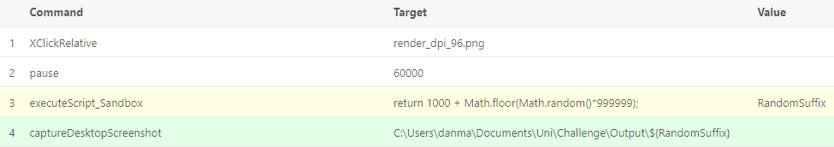

The RENDER function was meant to be outside the diagram, only called in the MAIN CONTROLLER function, where I can keep an iterating number to rename the file.

So the render doesn't keep overwriting itself.

I still have to change this subroutine to save the render and not screenshot, like John wants, but I’ll do that later.

The important thing is the Random Number generation!

It takes a number in 100,000 and appends it to the file name.

This is different every time, and if by some magic of probability if I get the same number twice, only the unlucky render is overwritten, the system remains robust and will not break!

This solution is far better than the last!!

After I fix RENDER to save and not screenshot the renders, I should be done with the development of the macros. I’ll probably move onto working on the next deliverables or do a bit of learning about AI Node-Based Diffusion to control StableDiffusion Models in Automatic1111.

# **Day 45 - Wednesday 21/02/2024**

Today I built my macro to save a render, now saving it and not just screenshotting it.

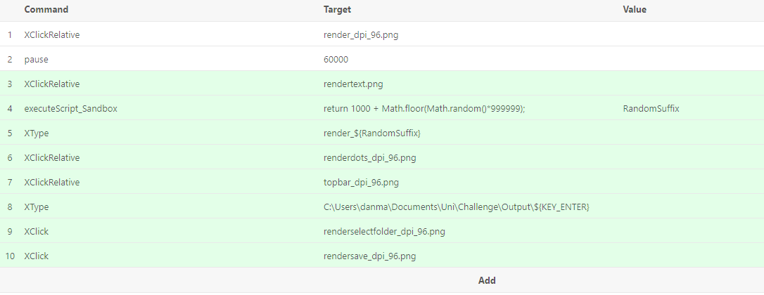

It extends on the maths based filepath, now using it as under the ‘name’ field in DAZ3D.

I also ran my macro from the very start, and had a bit of trouble with DAZ3D not opening through my .exe path in the INIT macro, but I got that sorted out quickly.

It just didn’t cose instances very fast, so I just had to work out the timing of the pauses.

The macro got as far as posing the model before meeting its first hiccup, just not opening and closing tabs just perfect enough for me to be fully trusting that it won’t misbehave and break while I’m not looking at it.

Sorted out another few hiccups, like me forgetting to include the macro which opens and closes the light tab in the super macro.

Small things, but they waste so much time to amend.

But when it works once, it works forever, so this little testing phase shouldn’t last much longer.

Soon, it’ll be working with AI. Looking forwards to the change of pace.

# **Day 46 - Thursday 22/02/2024**

Today, I had my meeting With John and Aidan. It was a day later than normal.

I got one big bit of feedback; my solution to the file name problem is flawed because of the risk of duplicate file names, and the fact that the file name given to the image dosen’t represent the contents of the image. Basically, the name of the image should describe the contents.

To achieve this, I’ll have to combine all of my controller macros into one, which shouldn’t take too long, but now I have to focus on the next submission.

I need to:

* Improve and extend my guide
* Write a blog giving understanding to my specific project and teaching the reader to use and extend my program
* Keep this diary up to date

My feedback for my guide from John is included below:

“67/100

Overall good progress on the project.

Overall the guide provides an improvement on the existing documentation but there are a still a few areas to work on for the how to guide:

One of your early screenshots which should say “add to chrome” is highlighting a button that says “remove from chrome”

Your ui vision example still refers to daz3d open and smile which might be confusing to the reader as you aren’t talking about that.

Don’t you need installation instructions for the Screen Capture XModule?

In the take information from the screen it would be good to have pictures explaining what this means the text is not very clear.

It might be a good idea to have a single thing that you are guiding the user to do and you use that to show each of the commands so that after describing a command you show working instructions someone can follow and what effect that has, i.e. combine the example with the command descriptions. The text descriptions alone are confusing to follow.

In the example it is also valuable to have screenshots so that a person following the instructions will see exactly the same thing as your screenshot and will therefore know they are doing the right thing.

Making content that strangers online are interested in is very valuable and takes a lot of work. It is worth putting the time in to try to do this as well as possible as well as possible as it will be very useful in the future but you are unlikely to be taught it explicitly. One thing that is good to do is to find people who can give you realistic feedback and to show them your stuff. You can also pass it to an AI and ask it what it thinks. You can do that both for the text and by taking screenshots and uploading the screenshot to Bard and seeing what feedback you get. It is also a good idea to be more explicit about how you are researching other guides. For example, showing that you are doing searches about the keywords your project is about and seeing what tutorials come up. Also finding a subreddit relevant to the project is good and seeing what tutorial style posts get high ratings. Even better to compare high and low rated posts to try to understand what is the difference between them. This shows that you are starting to focus more and learn more about promoting your work and creating guides that are useful to others.”

In summary, to improve my guide I must:

* Fix early screenshot that says “Remove from Chrome” instead of “Add to Chrome”
* Replace screenshots with ones of a fresh install of UI.Vision to avoid any confusion with my personal macros being in the background
* Include Installation Instructions for needed XModules
* Have more pictures and rewrite confusing text in “Take Information from the Screen”
* Rewrite examples and combine them more with the Command descriptions to make them more substantial
* Rewrite the ‘Step-By-Step Examples’ section to integrate more command explanation into the examples
* Add a lot more images into the Step-By-Step Examples
* Add summary screenshots along the Examples, so people can follow along
* Get feedback from somebody that knows about CS
* Get feedback from somebody that doesn't know much CS
* Pass to AI and get advice (maybe copilot?)
* Research other guides (good or bad) and take what I can learn from them - Reddit, Google Search
* Then use this new feedback to bring the Guide to its final draft

In the Canvas page for the final assignment, it gives good detail on the blog:

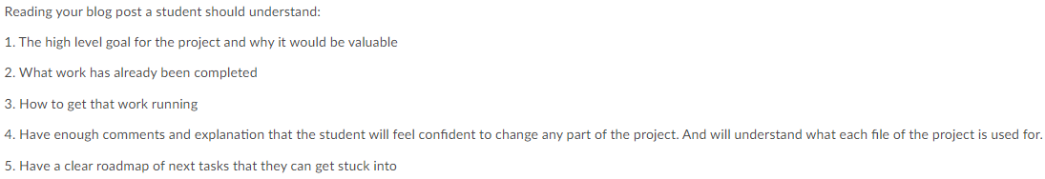

I think I will use these 5 points as my main sections of the blog.

# **Day 47 - Friday 23/02/2024**

Today, I looked through a few example blog posts. This one by Ethan Hanley, and this one on Gwern.net.

<https://www.gwern.net/GPT-2>

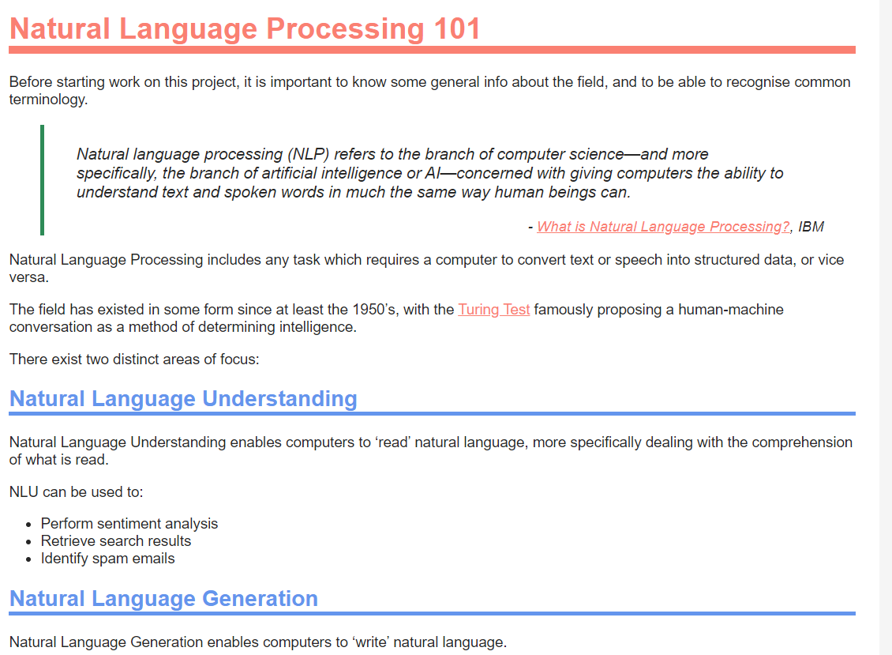

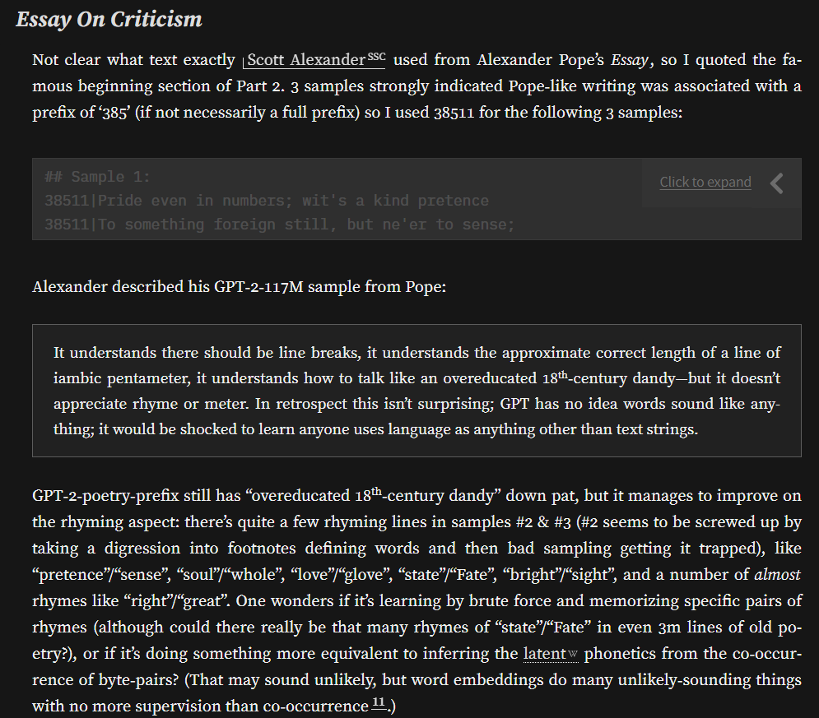

I’ve asked two of my friends from my pathway to look over the guide on Monday, so I’ll have to have the guide in a good state by then.

I can have a couple family members give it a look over, too.

Thus, I’ll have an opinion from a group of people with and without a good bit of CS knowledge, so it should be nice and varied.

Also, I’ve always wanted to check out Microsoft Copilot, so I had a good excuse to try it out. I gave it a big copypaste of my entire guide, and asked it for a critique.

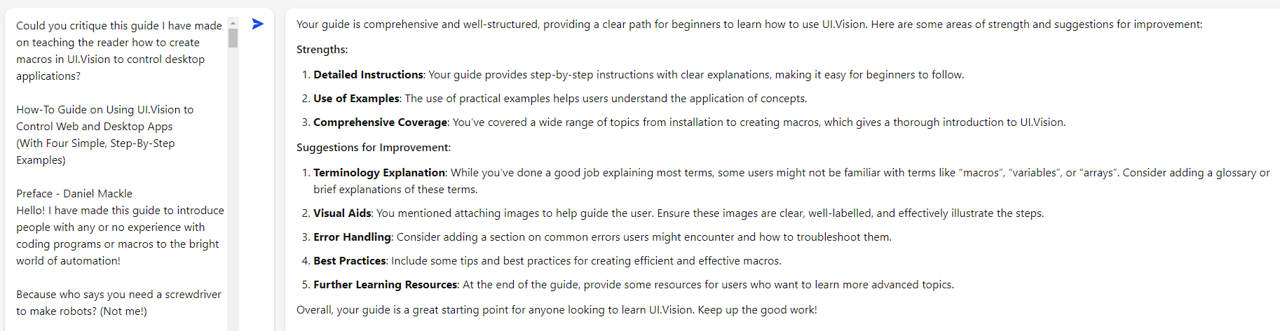

The prompt is on the left, the response on the right.

A few of the complaints are just because the images and links can’t be brought over into the prompt, but the main things are:

* Consider adding a glossary - I think I’ll do this. I’ll just put links down to it when I bring in a new term.
* Add a common errors section - UI.Vision’s language is really robust, but I think I should be able to include a glossary of a handful of errors, but it’ll have to mostly do things like wrong data type errors.
* Include more tips to make more efficient macros - I honestly don’t really think UI.Vision has much of a problem with efficiency, as it acts more of just a sequence of inputs. I don’t think this would be worth putting in.

I also need to ‘sell’ my guide, showing to the reader that It’s worth its while to be read.

To do this, I added a section near the start of the guide called How This Guide Will Help You, containing reasons why the guide is worth using, and how useful the gained skills will be.

# **Day 49 - Sunday 25/02/2024**

Today, I worked through the changes to my guide script,

* Fix early screenshot that says “Remove from Chrome” instead of “Add to Chrome”
  + With a new profile of chrome, I could install a fresh install of UI.Vision, with no risk to my original macros. I took this screenshot while installing it.
* Replace screenshots with ones of a fresh install of UI.Vision to avoid any confusion with my personal macros being in the background
  + I did this with the fresh install
* Include Installation Instructions for needed XModules
  + I actually found out that I didn’t need any XModules, so I told John about this, and included it in the extras section anyway
* Have more pictures and rewrite confusing text in “Take Information from the Screen”
  + I removed the most confusing text and replaced some of the text with images and added a new example with the section (with images) to help confusion
* Rewrite examples and combine them more with the Command descriptions to make them more substantial
  + Added more images and brought command descriptions from parts of the guide into the examples
* Add a lot more images into the Step-By-Step Examples
  + See above
* Add summary screenshots along the Examples, so people can follow along
  + Added along the steps, for reference if an error is faced
* Get feedback from somebody that knows about CS
  + Will do Monday
* Get feedback from somebody that doesn't know much CS
  + Will do Monday
* Pass to AI and get advice (maybe copilot?)
  + Done - See Day 47
* Research other guides (good or bad) and take what I can learn from them - Reddit, Google Search

Tomorrow, I will get feedback on my Guide, from my family and colleagues, and will change the guide to fit the advice.

But for now, I began on the Blog, identifying all the headings and sections in more detail:

1. Introduction - Brief, about what CSC1028 is
2. Why this Project? - Shows the goals of this project and why they are valuable
3. Before you begin - Small, pick-and-choose bits of advice that I would have liked to know going into CSC1028
4. Technical Stuff (& Useful Resources) - On definitions, explaining core concepts and linking additional resources that I used to understand the technical details around my project
5. Software - Describes the software I use for my project, with tips, pros and cons of the software I used, for the reader to identify if they want to use the same software as I did.
6. What I’ve Done - Shows my plan for my project, and the steps I took to achieve them (broad strokes)
7. How to use my Programs - Shows how to install and run my programs correctly.
8. Breakdown of my Program - File-by-file low-level comb through my code, showing techniques I used and problems I overcame
9. How you can Build on my Program - A handful of roadmaps showing how my program could be extended into multiple new functionalities, with radically different outputs

# 

# **Day 50 - Monday 26/02/2024**

Today, I started typing out the blog, working mostly on the Introduction, Before you begin, Technical Stuff and Software sections.

These sections are mostly just about giving a good image of the tools and concepts that surround my project, alongside showing my motivation for choosing this project, and what the reader can gain from working in this field.

I’ve included a handful of quoted definitions from some websites and guides that I used to build up a bit of knowhow on the area I would be working on. Most of the technical details are about AI Integration and Diffusion Models.

In the final HTML, the blog will have a lot of links to other sections of itself, and to the Guide. These will be used for quick reference to tutorials and explanations, so I won’t have to repeat myself in these areas. I can’t put in the links yet, but I’ve marked where I will put them.

Link to the blog post:

[Blog Post](https://docs.google.com/document/d/1rFdRnH2iIhS_BtOLI0gz24ezqZCQ60L7ilr53DSoBls/edit?usp=sharing)

Also, I got a couple of my friends from CS to look over the guide, Eshwar and Oliver. They said that it was fine, if a bit long. But they agreed that adding a glossary would make it better.

Tomorrow, I’ll have my parents give the guide a read over and see if it’s simple enough for someone with less programming experience to understand.

# **Day 51 - Tuesday 27/02/2024**

Today, I worked on more of the Blog, completing the ‘What I’ve Done’ and the ‘How You can Build on My Program’ sections.

I had a problem in the ‘What I’ve Done’ section. In the entire blog, I speak in the past tense as my audience is people in the following years who will take projects building on my own. However, I don’t know what to say for the parts of the program which I’ve not actually finished yet.

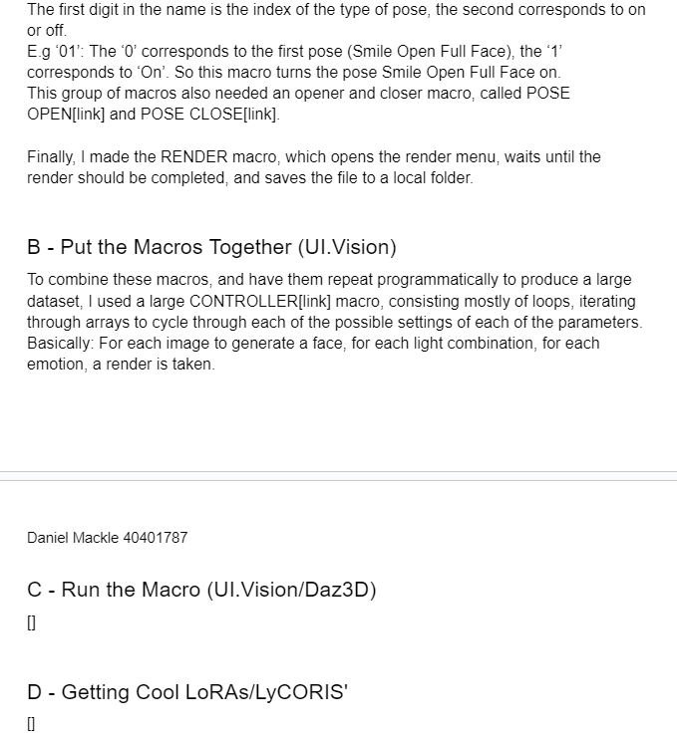

I’ll just have to ask John tomorrow.

I had a chat with Caleb today, about how the blog is going. He’s had the same problem as me about sections not yet completed, so at least I’m not alone.

We mostly ended up talking about new AI models though, and which was better at what functionalities.

But we agreed to check out and review each other's blogs in the coming days, so that’ll be sure to help us both.

Stuff left to do for Friday:

* Flesh out How to use my Programs
* Plan / flesh out Breakdown of my Program
* Generate a couple example AI images in Technical Stuff - LoRA/LyCORIS
* HTMLify w/ MS Word
* Split into pages
* Link links
* Add glossary to guide

# 

# **Day 53 - Thursday 29/02/2024**

Today, and for the last few days, I’ve just been amending my guide and writing the blog, bit by bit. There’s not much to write about. I only have to write a glossary for the guide and HTMLify and link everything up.

But, on top of just continuing to write, today I did a bit of research on problems people are having with UI.Vision.

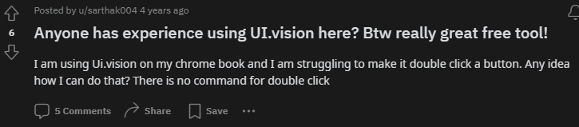

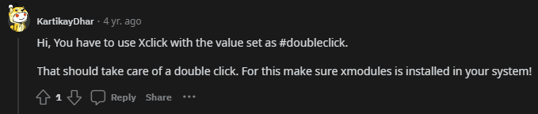

In this thread, a person didn’t know how to double click. I didn’t know about this functionality, so I would have just used XClick twice…

Adding this to the Guide at XClick.

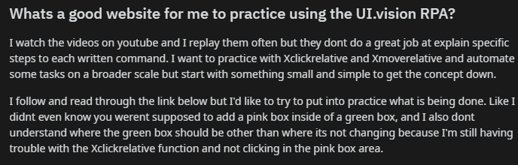

This person is confused about relative functions. The person probably had their Click area too big and their Anchor area too small or nonexistent, so the command wouldn’t execute reliably.

I have added these two tips to the section on relative clicks.

# **Day 54 - Friday 01/03/2024**

Today, I searched google a bit to try and find any other things I could add to my files for a final finishing touch.

I found this forum post asking for a simple ‘Getting Started’ manual for UI.Vision. Have I got good news for this guy.

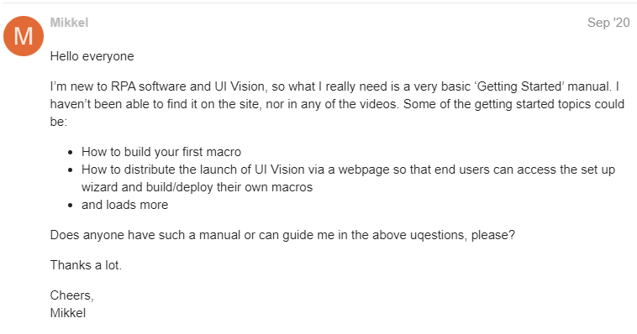

And then I found another!

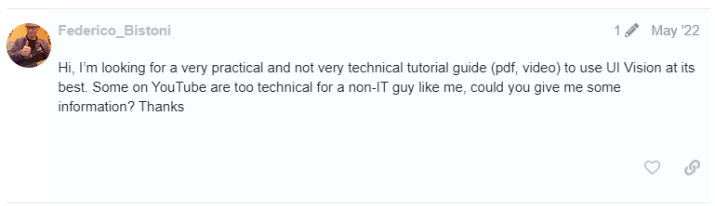

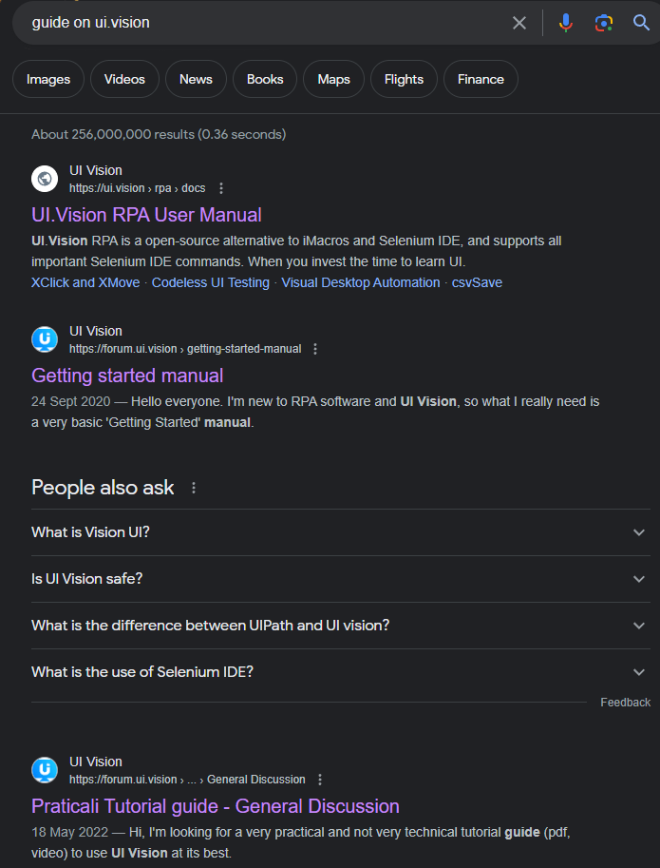

And these were the first two things to show up under the official documentation.

Honestly, the only thing I really found with google searches was that there’s a real lack of guides for UI.Vision. I couldn’t really take much advice on how to improve my own.

I also did the final touches to my writing for my guide script and my blog post. I added my Glossary to my guide and implemented the changes based on the research I did yesterday.

I used Microsoft Word to convert my .DOCX files I downloaded from google docs into .HTML files. I also applied my .CSS from my previous .HTML files to the new ones, to give it a bit more *style*.

I then linked up all the (many) links in my web pages. I didn’t know how to link to a different position in the same file, but I had to learn it for this.

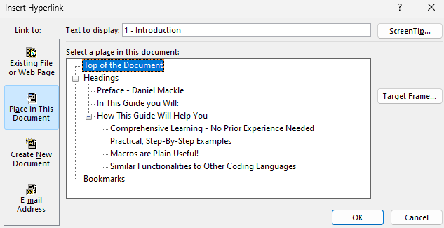

Very nice!

I finally threw together a small readme for John and sent it off.

Phew!

I also looked over Caleb’s blog and gave a bit of feedback on it. Looks good!

# **Day 59 - Wednesday 06/03/2024**

Today, I had my meeting with John and Aidan. We talked more about the future of development of the project.

In summary:

* So far, we have made a general program which is impressive, but does not meet many functions which could be useful to the users. It is not yet viable in the greater market
* We have to work on condensing this general program into a more specific solution, which has an obvious use to the users
* So, something which makes a pathway easier or solves a certain problem
* In my case: That’s simplifying the time-consuming and expensive process of making the resources to make a PNGtuber
* I should research the current PNGtuber field:
  + Compare good vs bad PNGtubers - what makes them special?
  + Look at the most used programs to run them - what does it need?
  + Get feedback to help specify my requirements
  + Find out what the target audience of my program is…
  + …and what they want
* From these, I will develop a high-level plan then low-level requirements to work on in the coming month
* I’ve been told to bear in mind that a less technically impressive product which is interesting and useful to the target audience is better than a more technically impressive product which is less useful to the target audience - example of <https://www.synthesia.io/>

I’m still pretty focused on my Databases Coursework, but it’s a lot easier than this. I should be getting it done this working week, then my attention is right back onto this.

**Day 61 - Friday 08/03/2024**

Still doing a lot of my databases, due next wednesday. I’m going to be away this weekend, so I’m mostly focusing on getting it done comfortably, but I’ll keep the diary going.

Today, I did a bit of research into PNGTubing, on the commonly used programs to run and make them.

[【Vtuber Tutorial】✦Time to Become a PNGtuber!✦](https://www.youtube.com/watch?v=plXx9D0pkWg)

This video was useful at giving a basic outlook on popular and simple guides.

The most promising two were:

<https://olmewe.itch.io/veadotube-mini>

and

<https://reactive.fugi.tech/>

The first one, veadotube mini, is great because it only really requires four images. One standard image, and one talking image. And the two with their eyes closed.

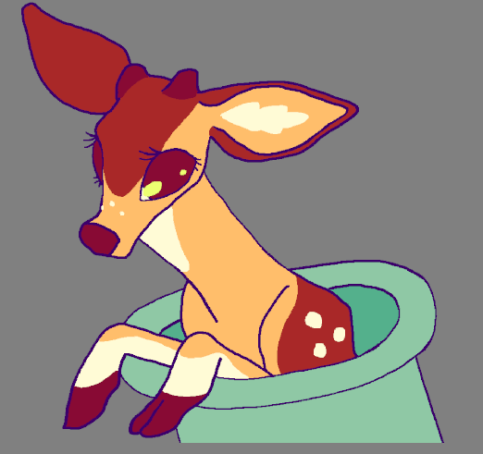

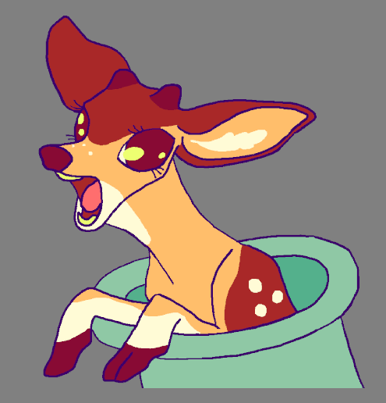

But, there are a lot of extra things to make it more emotive, like having different modes based on emotions that can be cycled through via hotkeys.

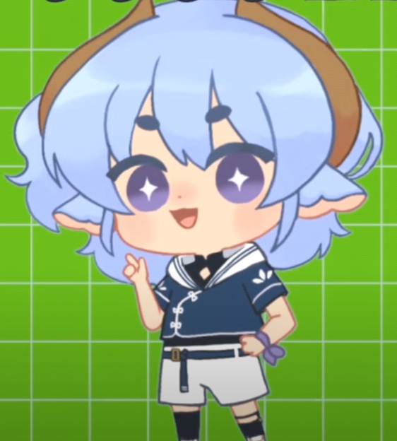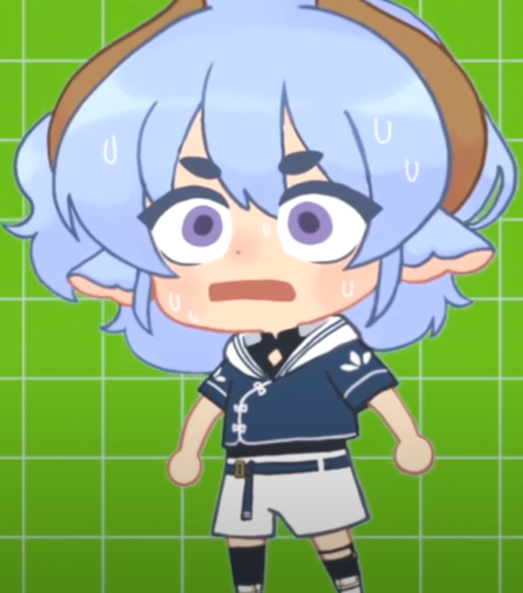

These are easily made, and my model could be posed into these emotions via daz3d.

# **Day 66 - Wednesday 13/03/2024**

For the last while, I’ve been focused on my DB project. But now it is all done and I can focus on this project.

For today's meeting:

1. I’ve been given these resources to focus on the business startup aspect of the project:
   1. [How to Measure Anything — LessWrong](https://www.lesswrong.com/posts/ybYBCK9D7MZCcdArB/how-to-measure-anything#:~:text=The%20book%20opens%3A,more%20than%20you%20knew%20before.)
      1. A big document on skills to find out if your software is useful - will read this over the week
   2. [How To Build Product As A Small Startup - Michael Seibel](https://www.youtube.com/watch?v=kzVvjKLdAbk)
      1. Talks about splitting the problem into easy, medium and hard problems
         1. Prioritise hard problems that have not been done by your competitors, giving you as functionality that they do not possess, making your product more desirable as an automatic pathway to answer that problem
2. I have been given advice about developing a project to be useful to people, and thus be successful
   1. Find my target audience (PNGTubers) and stick to them - do not radically shift your target just to get a more technical project (E.g synthesia)
   2. Find out what this target audience wants to pay for through market research and existing successful projects
      1. Find the existing low-end affordable software
      2. Find the high-end expensive software
      3. Identify what makes the high-end software good, build on it and charge less than the high-end software
      4. Your software should be desirable!
   3. If this does not happen, you can either:
      1. Build on your product until it is desirable (E.g Twitch)
         1. E.g In twitch, they began with an undesirable product, but identified what their audience wanted and slowly transformed their product into a desirable service.
      2. Rebuild your product to attempt to adapt it to another audience
         1. E.g turning your product from a fully paid software to a free-to download software with some paid features or a donation-based payment system

Today, I also looked up about <https://reactive.fugi.tech/>

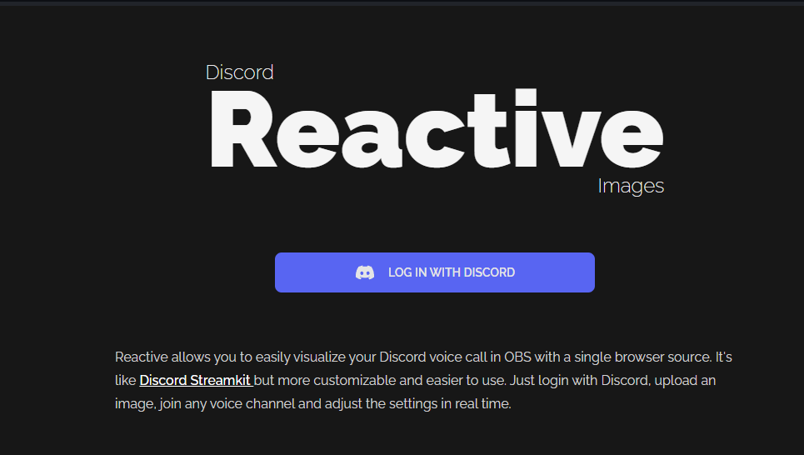  
It is very popular, and interfaces with Discord <https://discord.com/> to create a very basic VTuber.

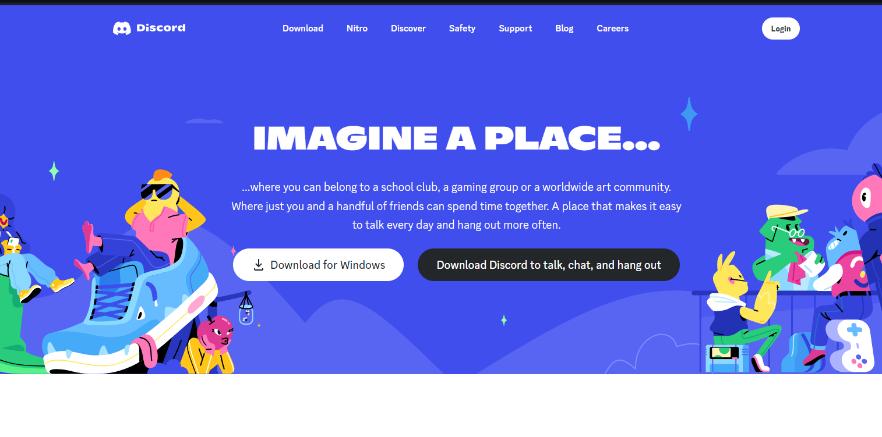

I have found an advanced guide for it below:

<https://grifnmore.com/sound-reactive-talksprite/>

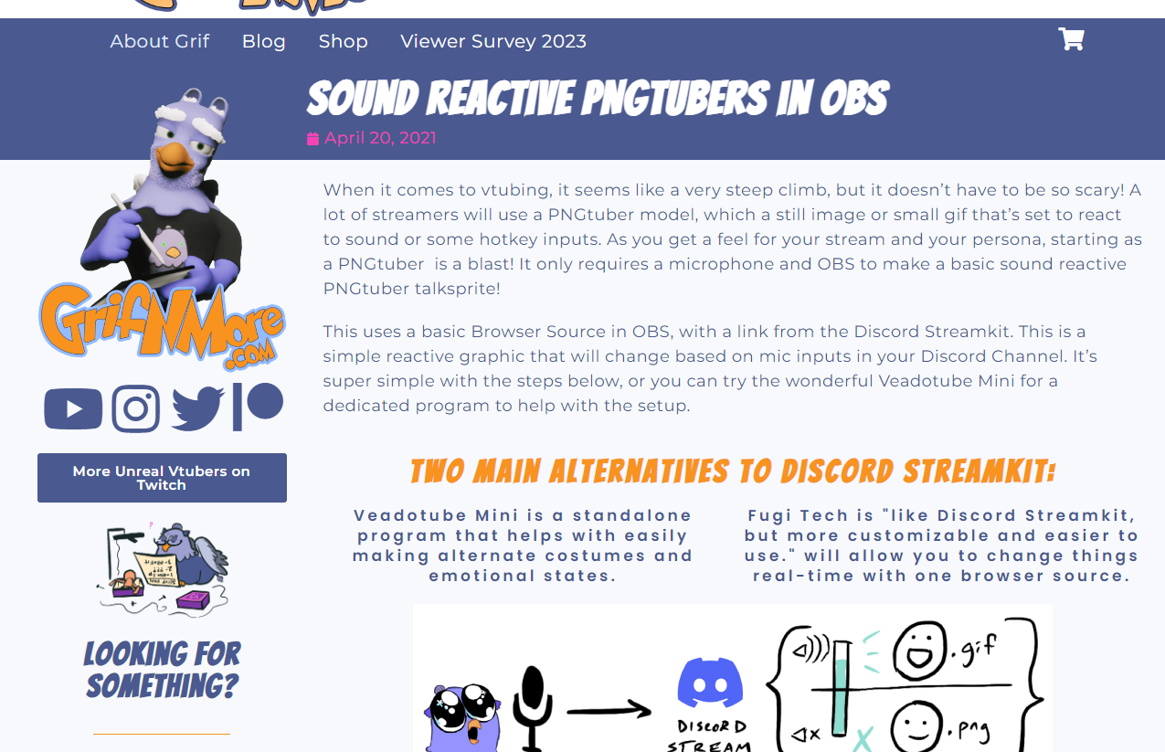

But to simply make a Sound-Reactive Sprite, only two steps are needed:

1. Have an active image and a speaking image
2. Run OBS <https://obsproject.com/>
3. Follow the steps in <https://reactive.fugi.tech/>

Every software so far has always used OBS to <https://obsproject.com/> manage the stream.

It seems to be the industry standard for PNGTubing.

It is a free, open source streaming software.

# **Day 68 - Friday 15/03/2024**

Today I checked out a handful more common PNGTubing apps.

PNGTuber Maker: This software offers an amount of stock PNGTubing models with accessories, and also allows for you to upload your own, again only needing images. As this model allows you to turn off blinking, only two images are really needed to make a model. This software is a good bit more bulky than the other models I looked at on Day 61, but stills serves a similar purpose.

<https://store.steampowered.com/app/2266940/PngTuber_Maker/#:~:text=PngTuber%20Maker%20is%20a%20free,for%20this%20software%20are%20positive>.

PNGTuber Plus: This software uses layers instead of just messing with the image files of the PNGTuber. It is more artistically-focused. This software makes PNGTubers out of smaller layers, but looks better and more fluidly moving by the end. It isn’t too applicable to me, though, as my project will not generate layers of a mode.

<https://store.steampowered.com/app/2596880/PNGTuber_Plus/>

Here is a video guide for PNGTuber Plus:

<https://www.youtube.com/watch?v=sN6JOp-IKuM>

Also, this software stands out from the rest as it is continually supported and updated:

<https://www.youtube.com/watch?v=NQ_-jfWBtQc>

And also the author seems to be very active and supporting users of the software:

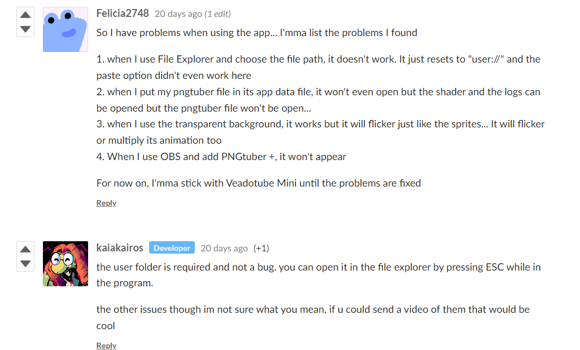

Taking notes!

# **Day 69 - Saturday 16/03/2024**

Nice.

I’ve done a bit more looking into Veadotube Mini, as I think that, so far, it seems to be my best bet.

I’ve chosen it because:

1. Only four images are needed:
   1. Eyes open mouth closed
   2. Eyes closed mouth closed
   3. Eyes open mouth open
   4. Eyes open mouth closed
2. But many more images can be supported:
   1. E.g in groups of the four above but with different emotions
   2. In the same groups but with additional aspects e.g a different outfit

It is lightweight and very simple, but has just enough features to accommodate great amounts of creativity

Additional emotion can be displayed via three movement settings:

* Closed mouth motion
  + Animates the two non-speaking images
  + E.g vibing - lazily moves side to side

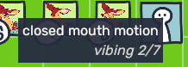

* open mouth motion
  + Animates the two speaking images
  + E.g shaking - sharply shakes up and down, good for showing fear or nervousness

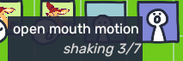

* mouth transition
  + A small, one-time animation that plays when transitioning from a closed-mouth to open-mouth sprite E.g Jump on Talk - which makes the character jump up a little bit when transitioning - makes the character more excitable and spontaneous, almost as if they are chipping into a conversation.

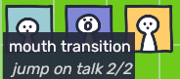

I have also checked the itch.io devlog of this software:

<https://olmewe.itch.io/veadotube-mini/devlog/691267/the-march-devlogue>

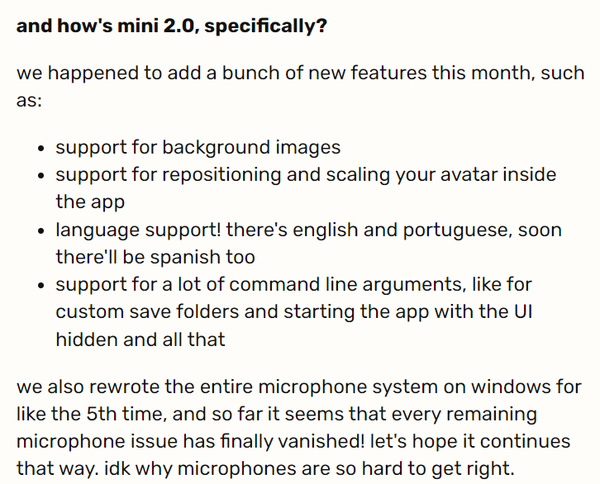

The author is still working on their product! And they expect to put out an open alpha of its second iteration next month!

After I have finished my final deadline, checking out and implementing the improved software could help further my project.

# **Day 70 - Sunday 17/03/2024**

Now I have identified the specific software and thus the pathway that I’ll be trying to implement my project into:

1. Person wants to make a pngtuber.
2. Using my project, a face, a prompt and a LoRA, the four images for one mode’ (e.g emotion) this is the bare minimum, and this step can be repeated for more modes.
3. Using Veadotube Mini and OBS, they can use the images to make their pngtuber and stream with it!

Opposed to the industry standard of:

1. Person wants to make a pngtuber
2. Person commissions artists for the minimum of 4 sprites (or draws the sprites themselves) - this step requires either money or a high entry level of artistic talent
3. Using Veadotube Mini and OBS, they can use the images to make their pngtuber and stream with it!

By using my software to get around step 2, the point of contrition which stops many people from being able to get into pngtubing has been avoided.

This is desirable to many people, and they will prefer to buy a one-time purchase software instead of the cumulative cost of commissioning more and more art for sprites.

This is the audience that I will try to satisfy with my project.

Replacing step 2 is my main goal, and my project will not be complete without it.

To achieve this:

1. I will create an offshoot of my macro program which is hard-coded to produce the sprites needed.
   1. It will input a face for face-generation as before
   2. The four poses will be similar, only really having changed blinking eyes and an open/closed mouth
   3. However, the macro will play again, doing the same procedure with a different, full body pose which gives an exaggerated emotion (e.g shocked)
   4. Step c will occur for as many poses as I code in
   5. It will output the posed renders in groups of 4 as named .png files
      1. The names will correlate to the contents of the file
2. I will find and download an amount of LoRA and LYCoRIS files and package them with the software, alongside my user guide, which explains how to use them with StableDiffusion to produce stylised image outputs

On the low level, my Macro will: (Code previously completed in **bold**)

1. **Open DAZ3D**
2. **Load the nth posed file**
3. **Use the input image to generate a face**
4. Pose:
   1. **Default**
   2. Talk
   3. Blink
   4. Talk & Blink
5. **For each pose, render and save the.png under an original name corresponding to the contents of the image**
6. **Close DAZ3D**

As you can see, I have already completed the majority of the functionalities of this program in my original macro program. My development of this more specified offshoot macro will mostly consist of correctly moving across my functional code, with little actual development.

Once this macro is complete, I will touch up my existing coursework and create both a social media post and a testing plan. Then I will spend the rest of my time implementing as much AI automation of Stable Diffusion as I can. The pathway is still complete without this functionality, but it would be great to fully automate the pathway by my deadline.

# 

# **Day 73 - Wednesday 20/03/2024**

Today I had an online meeting with John Bustard.

We went over the work I’ve done over the last week, and he gave me a bit of advice:

1. I should sum up my research and sort them as potential changes to my plan, scoring them in difficulty and the improvement they would offer.
2. I should continue a bit of market research on the side, but move on with my coursework and coding now.
3. I should start my testing plan, updating my blog post, creating a github page and making a social media post.
   1. Testing Plan:
      1. There’s not much previous work to base this off, it’s very simple. I’ll just go through my original macro step by step, create tests to see if the program is functioning as intended, and show what a successful test looks like.
      2. Should be in one word document
      3. If I begin progress on my 2nd macro, do a testing plan for that too
   2. Blog Post:
      1. I will summarise my feedback from Assessment 2 and show my completion of them, similar to what I’ve done when writing assessment 2.
      2. Then I will complete them one by one, noting how I fixed them
   3. Github page:
      1. I have already made an account
      2. I have already uploaded my macro
      3. I just have to dress it up nice with a readme and other stuff

# **Day 74 - Thursday 21/03/2024**

I actually noticed I haven’t put my feedback from Assessment 2 here, so:

“70/100

Great focus on the students perspective at the start.

We aren’t trying to create vrm files which are 3d models with poseable skeletons. We want to create a ‘png tuber’ where the system picks from a set of sprites to show based on the pose and expression of a person ‘puppeting’ them using a webcam.

For the diffusion model example I would show a face that is described and then show how img2img with one of your renders produces a face close to the example showing how the image is controllable using the reference image. Also show an example of stylisation e.g. convert to photoreal and to cartoon.

Clear description of the steps and how they work. No mention of how you create the filename and use it to document the settings of the rendered file. Or rather you describe the random number generator version, which I would definitely comment on as being something that needs changing. Your diary talks about text for this but it isn’t in the blog post and not in the next steps. You didn’t mention the hair (if you aren’t sure about this you can just have a large number of hair styles added to the model and then hide or show them to pick which haircut the character might have).

Also no mention of working back from what is needed for a vtuber/comic/movie. I talk about this at most meetings but you haven’t acted on it. The examples you render aren’t working towards a well defined goal yet i.e. the poses and lighting settings aren’t chosen based on need for an application (no mention of expressions for example).

Your next steps also don’t talk about how you will do the img2img processing which is the next big step.

Great that you got other people to look over the report to give you feedback as well as getting improvements using copilot. Good improvements to the how to guide.

Great that you looked at social media posts to inform your guide.

Overall your blog post and how to guide updates are clear and helpful and your polish of them from a user perspective with student and AI feedback and social media searching is excellent. The main areas to focus on are having a clearer understanding of the goal of the project and communicating that. Especially understanding what we are trying to create and making sure you ask questions if what I am saying isn’t clear. E.g. how to use comics, movies and png tuber software to priorities the assets we record. Also making sure that you are providing guidance that is complete. Talking about all the parts needed to complete the project including parts you haven’t completed yet. Being clear about what is completed and what isn’t. So someone is not confused because important parts are missing or with code like the random filename. The reader shouldn’t have to work out for themselves was needs to be done to make the project work.”

So, summarised:

1. Specify about PNGTubers more than VTubers, make clear that VRM models will not be used, but .PNG files for sprites.
2. Talk about my next steps to replace the RNG filenames with sequentially named filenames which describe the contents of the image
3. Mention ideas on how hair could be implemented
   1. Hair model layered and invisible on the head, giving another attribute
   2. Hair models placed on at the user’s discretion
4. Add a section about requirements needed for VTubers, Comics, Movies to the things to do next, and PNGTubers to the intro
5. Add a section about the goal talking about the current audience, current user-bases and market research
   1. Talk about specifying the macro with posing functionalities to pander to a PNGTuber market
6. Talk more about img2img processing in the Things I’ve got done section
7. Communicate clearer my goal of the project - add to The Goal section
8. Talk more in detail about parts of the project I haven’t done yet
9. Have a section of what isn’t completed yet
   1. So the next developer doesn't need to research the next steps to completing my program proper, alongside the already made section on extending the program

# **Day 75 - Friday 22/03/2024**

Today, I looked over my previous research, summing up the potential for integration of my software to different PNGTubing software, to improve the overall solution, increase my user base and make my solutions more desirable to potential buyers.

1. Add support for another pngtuber making software. This would make my solution an option for more people and thus diversify my user base drastically:
   1. Discord Reactive Images:
      1. Benefits:
         1. This is a simple, light software which requires very little input to make a PNGTuber.
         2. Support could be completed quickly
         3. It has a large user base, so it would appeal to more users
      2. Downsides:
         1. Nearly all of the functionalities of Discord ReactiveImages can be emulated with the current Veadotube Mini, is this change necessary?
         2. Discord Reactive Images only requires one image. Thus, commissioning an artist to draw a single image of the avatar is much more desirable. The output of my system would have to be of a high quality to compete.
         3. Discord Reactive Images only requires one image. Thus, my dataset-oriented program may not be very suitable.
      3. Overall:
         1. Discord Reactive Images is a light and well used software. If I am sure I can compete with the current DRI pathway, which is much less in need of a solution than the rest of the pngtuber software, there are many benefits.
         2. Achievability: 3/5
         3. Improvement: 4/5
   2. PNGTuber Maker
      1. Benefits:
         1. This is a heavier application, with many functionalities, attracting more experienced and dedicated PNGTubers
         2. The many functionalities give us a great degree of scalability for this offshoot of the program
         3. Self enclosed - OBS would not be needed - gives better quality of life for users
      2. Downsides:
         1. Support would take a lot of effort and time
         2. It has a smaller relative user base, so it wouldn’t appeal to as many users as other options
      3. Overall:
         1. This self-enclosed, heavier software is all that an experienced PNGTuber needs, but is very hard to use and learn. Thus, it is harder for me to integrate and also has a lower user base.
         2. Achievability: 2/5
         3. Improvement: 3/5
   3. PNGTuber Plus
      1. Benefits:
         1. This is a light application (but not as light as DRI), with a handful of properties, attracting a mix of experienced and non-experienced PNGTuber
         2. This application is not fully enclosed, and needs OBS. The benefit of this is that it is easier to make as OBS integration is not a requirement.
         3. Self enclosed - OBS would not be needed - gives better quality of life for users
         4. PNGTuber Plus is a software based on complex layers. The benefit of this is that animation is very easy and looks very good. This attracts a smaller but artistic, high-quality user base of VTuber developers.
      2. Downsides:
         1. This application is not fully enclosed, and needs OBS. The downside of this is that it is less handy for users, as they will need to install PNGTuber Plus, my software and also OBS.
         2. Support would take a good amount of effort and time
         3. It has a small relative user base, so it wouldn’t appeal to as many users as other options
         4. PNGTuber plus is a very hard to use software, which reduces the active user base which I am trying to promote my software to. This integration may not be worth the effort.
         5. PNGTuber Plus is a software based on complex layers. The downside of this is that it would take a lot of manipulation of my software to integrate this software. This makes the solution a lot harder to code.
      3. Overall:
         1. This is a very hard to use software, thus making my solution very difficult. Its layer-based system (opposed to the usual sprites) makes my program not too suitable in its current state, and would need a lot of work. If I did integrate this, it still would not appeal to a very large group of potential buyers. Not enough to make it worth the effort.
         2. Achievability: 1/5
         3. Improvement: 2/5

# **Day 76 - Saturday 23/03/2024**

Today, I began my work on modifying the Blog Post.

I will update this page as I update the blog post in the next days, showing how I have tackled each problem:

(Bold: Completed on 25/03/2024) (Bold+Italics: Completed on 26/03/2024)

1. Specify about PNGTubers more than VTubers, make clear that VRM models will not be used, but .PNG files for sprites.
   1. ***Completed. Changed the Goal section and added a bit about PNGTubing.***
2. Talk about my next steps to replace the RNG filenames with sequentially named filenames which describe the contents of the image
   1. ***I have mentioned in RENDER to refer to section 6.***
   2. ***I have added a section to section 6 on sensical file names.***
3. Mention ideas on how hair could be implemented
   1. Hair model layered and invisible on the head, giving another attribute
      1. ***I have added a section to section 6 about this new attribute idea***
   2. Hair models placed on at the user’s discretion
      1. ***I have added a small section on adding hair models and other cosmetic changes manually to the What I’ve Done section***
4. Add a section about requirements needed for VTubers, Comics, Movies to the new Market Research section, and PNGTubers to the intro.
   1. **In the new Market Research Section, I now speak about this in detail**
5. Add a section about the goal talking about the current audience, current user-bases and market research
   1. Talk about specifying the macro with posing functionalities to pander to a PNGTuber market
      1. **In the new Market Research Section, I now speak about the research towards my PNGTuber macro to be made in detail**
   2. Communicate clearer my goal of the project - add to The Goal section
      1. **In the new Market Research Section, I now speak about my goal, and how I used Market Research to better define and make a plan to meet my goal.**
6. Have a section of what isn’t completed yet
   1. So the next developer doesn't need to research the next steps to completing my program proper, alongside the already made section on extending the program

Today, I worked on documenting my revised goal, and my analysis of the market in preparation of the creation of my new macro. Out of the 7 things to do to my Blog, I got 5 of them done.

Here is an example of my new Blog section (I mostly based this section off the evidence I’ve gathered in this diary):

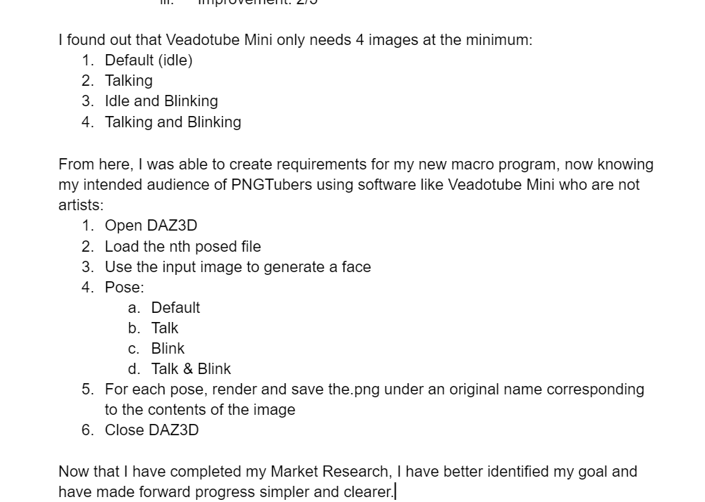

# **Day 77 - Sunday 24/03/2024**

Today, I kept chipping away at changing the Blog Post. I only have to add a section on things I have not yet done then I am finished with the blog.

I also spent some time today researching PNGTubers on my own accord.

I looked through 2 of the most popular ones currently active on the twitch category PNGTubing, and then I chose 2 random, less popular competitors.

I watched 20 mins of each, guessed their PNGTubing platform, and estimated what I thought made their model more successful:

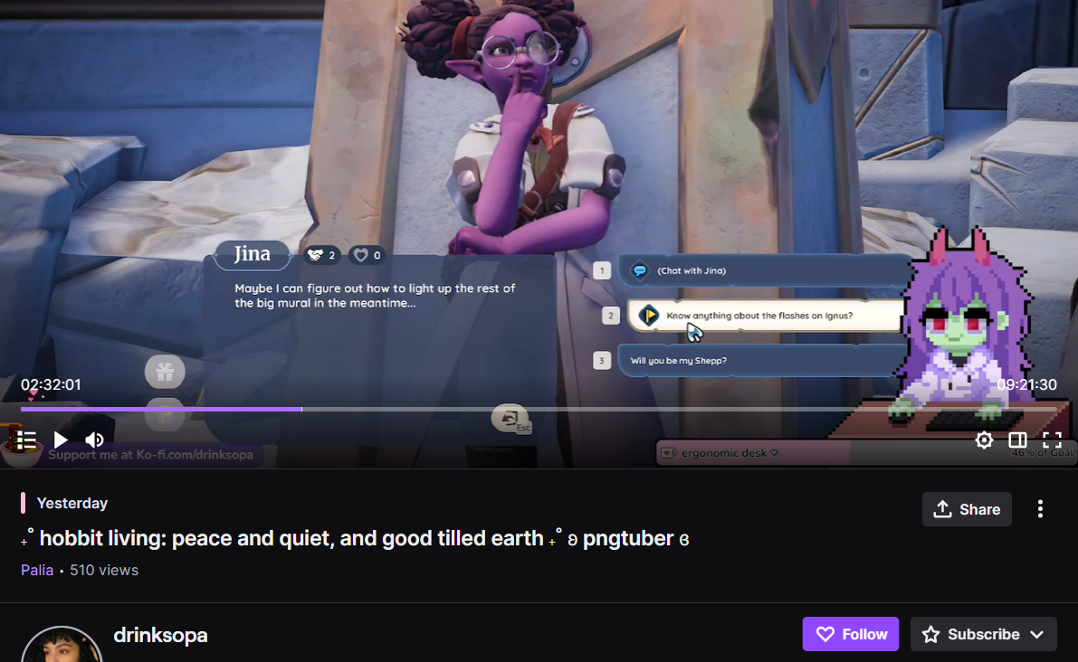

The first PNGTuber I researched was drinksopa, with 510 viewers at the time of joining.

She was playing a relaxing game and used a pixelated hand-drawn PNGTuber model. I only saw her using a single ‘mode’ of sprite, but I’m sure she has more, given she is so popular.

Things I think made her successful (aside from personality):

* Relaxing vibe / game works well with relaxing pixelated pngtuber
* Even with only seeing one mode, the model is very emotive, blinking, mouth moving and hands moving according to the positions of the mouse and keyboard in real life.

However:

* PNGTuber model does not flow and move when not speaking, and does not jump to catch attention when beginning to speak
* Does not change modes very often, not changing over the 20 mins i watched

The hands are mapped to the keyboard and mouse inputs, so I am quite sure either PNGTuber Maker or PNGTuber plus was used, as they have that functionality. But PNGTuber plus has a very flowy, layered style, which is not present. I conclude that PNGTuber Maker or a software I have not yet researched must have been used.

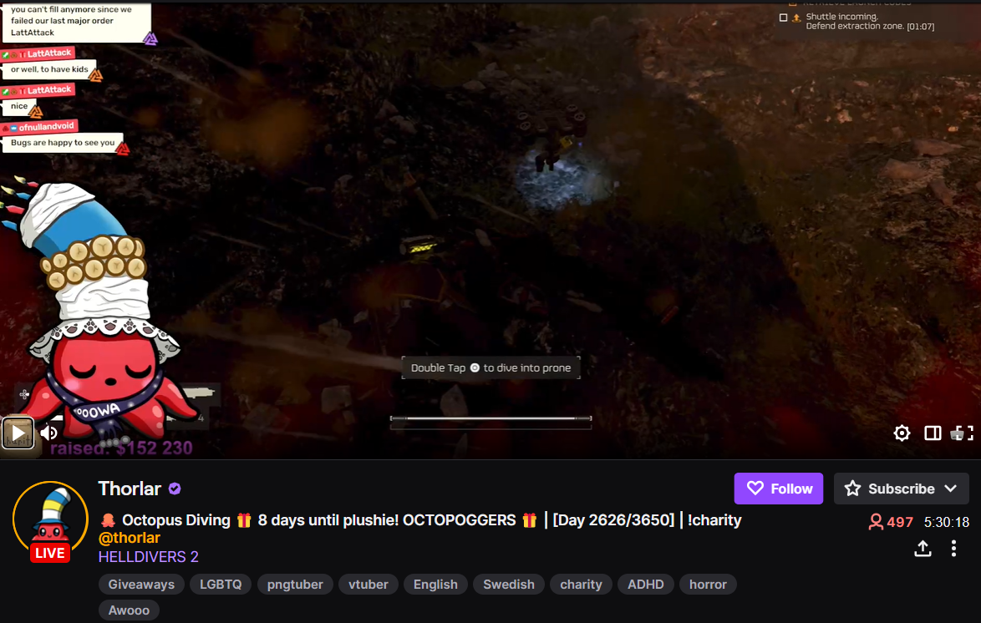

The second, well-known PNGTuber I researched is Thorlar, using an avatar of an animated octopus. I knew immediately that PNGTuber Maker was also used for this avatar, as the faces and emotions used use their stock assets, even though the rest of the model is hand-drawn.

Thorlar had 497 viewers at the time of viewing.

Things I think made him successful (aside from personality):

* Funny avatar which is extremely emotive and goes through many modes i saw (happy, sad, sleepy) in the 20 mins
* Certain things could happen to the avatar if the audience paid a certain amount of money (in the form of twitch bits). This is why he is currently wearing a scarf - the users can ‘dress him up’ at a price. This brings an amount of audience engagement

However:

* For each mode, there is only the 4 basic icons (open eyes, closed eyes, open eyes talk, closed eyes talk)

The function of interacting with the avatar seems to be pretty common among very high-budget models as it gives a lot to the stream and makes the twitch currencies of bits and points a lot more valuable.

I actually found a guide on how to plan and achieve this sort of functionality:

<https://learn.ganknow.com/course/chat-interaction/>

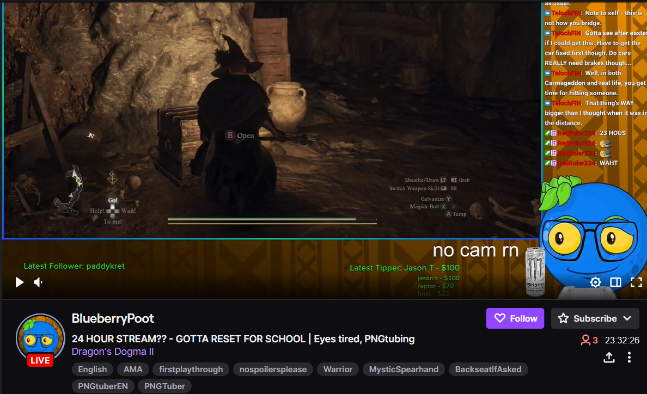

For my first of the less popular PNGTubers, I watched BlueberryPoot, at 3 viewers.

I noticed he was a lot less vocal than the previous two, who acted more like performers, but it’s only natural.

For his model, I expect he used PNGTuber Plus, as it was very floaty and used sprites. The glasses, eyes, mouth, eyebrows and drink were all separate layers, and had different movement settings (E.g the drink does not move at all).

Things I think made his model less successful:

* The avatar does not have any modes aside from the standard one
* There is no audience participation with the model
* Although looking funny, the model doesn't have much else going on

However:

* The layering is well done, and could be used to quickly and easily change and add new funny things to the model through PNGTuber Plus

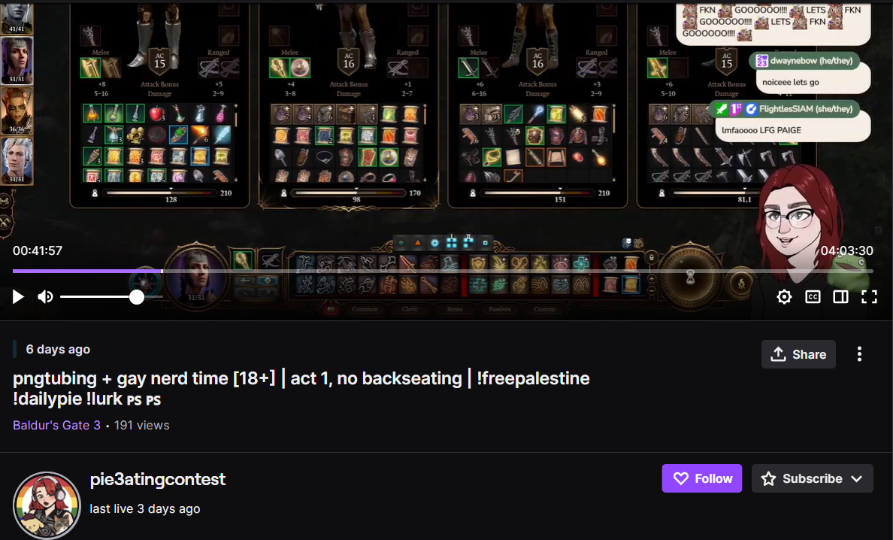

This final PNGTuber, pie3atingcontest is more popular than the prior, at 191 views at the time of entering.

I think I enjoyed her stream the most, as she was funny and had a lot of user interaction via the online chat, which she always made sure to keep tabs on and reply to. But maybe i was a bit biased because;

Her model was very obviously using veadotube mini, as it had the ‘jump’ animation which always plays at the beginning of talking using that software.

It also had the ‘vibing’ effect of veadotube mini when not talking. Similar to veadotube mini, it only used the 4 common images. I only noted one ‘mode’ being used.

Things I think made her model less successful:

* The avatar does not have any modes aside from the standard one
* There is no audience participation with the model

However:

* The features of veadotube mini allow the avatar to always keep moving, the movement depending on the current state (talking, not talking, blinking, beginning to speak) to give character
* The avatar jumps up once when beginning to speak, catching the eye of the viewer, making the avatar seem more human, as if it is chipping into a conversation or is full of energy

# **Day 78 - Monday 25/03/2024**

Today, I finished off the final section of the blog post, writing about what I have not yet done, making it clear where the user should go from here to complete my main functionality, saving them time by preventing them from needing to research their own high and low level requirements. This is all in the new, rewritten section 2 - My Plan (And What I’ve Done). In this I also speak more about defining my specific goal, as I do in the new section 3 on Market Research.

For the rest of the day, I spent my time collating the information I gained from researching the PNGTubers yesterday.

PNGTuber Maker was used 2/4 times.

PNGTuber Plus was used 1/4 times.

Veadotube Mini was used 1/4 times.

Discord Reactive Images was used 0/4 times.

PNGTubers using PNGTuber Maker used its greater range of functionality to integrate cool things like Twitch Integration via donations and Mouse and Keyboard Mapping.

The two most successful PNGTubers used PNGTuber Maker.

PNGTuber Plus and Veadotube Mini were used by the less successful PNGTubers.

The most successful PNGTubers do their best to engage the audience with more high-end and fun functionalities which they can directly interact with, and they also have different modes, which they cycle between using hotkeys.

From this I can estimate:

* PNGTuber Maker seems to be the most popular among active streamers
  + As it has support for higher-end, fun functionalities…
  + …which engage the audience, giving more success and donations
  + This supports them to bring forward more functionalities like different modes and tools
  + Thus, perhaps heavier, more functionality-full software appeals more to serious, successful PNGTubers, even though it is more difficult
* Veadotube Mini and PNGTuber Plus compete with this software, but lack the large functionality PNGTuber Maker possesses
  + Thus, perhaps lighter, less functionality-full software appeals more to early, less popular PNGTubers as it is easier to grasp…
  + …but they earn less money as they have a harder time maintaining viewer retention…
  + Thus earn less money through donations and viewers

From this, I estimate that maybe there is some sort of stepping-stone based cycle going on, where early PNGTubers are drawn into the industry via smaller, lightweight and easy to understand programs (like DRI and Veadotube Mini). As they grow more successful and become more experienced, they move onto the more heavy and functionality-driven software like PNGTuber Maker as it is more profitable, professional and high–quality, regardless of the significant buy-in and learning curve.

# **Day 79 - Tuesday 26/03/2024**

Today, I have finished my Testing Guide, and I have added it as a final section to the end of my Blog Post. In it I went through each step of the macro, with screenshots, describing what the user would expect to see and what potential errors and solutions may have occurred if the robustness of my program is breached in an exception or logical or runtime error.

I did this 15 times for 15 steps.

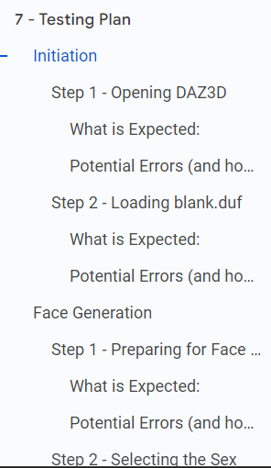

Today, I also commented every line of my macro code. It didn’t take long as I had a good deal of them beforehand.

I also added a section to the blog where I spoke about lines of code that should be localised before use on a different computer. This is in section 4 - Localising File Paths.

Now all that is left to do is write my social media post, create the readme.txt for my github, and HTMLify my blog again. I can easily get that all done, as long as I don’t get a lot of feedback to change in the final meeting tomorrow.

I have until a minute to Friday to get these finishing touches done, so I’m not too stressed.

# **Day 80 - Wednesday 27/03/2024**

I got this amount of feedback from my online meeting today:

* Add a section at the start on the technical innovation which inspired me
  + **I did this - It is at the very start of my blog. I talk about the recent strides in technology which allowed my project to begin**
* Mix around my Blog Post to make the ordering more coherent
  + Some points are high-level when they should be low level at that point
    - **I made the requirements in the market research higher level and more detailed as it is the first time the user reads this**
  + Things defined before knowing that they're needed
    - **In the new Technical Innovation section, I mention and introduce all of the terms**
* Add a section to the start of the Testing Plan about high-level requirements and how errors or faulty edge cases can prevent the functionality from completing
  + **I added both a section about Requirement Testing and a section on Edge Cases to the testing plan**

I then amended all of the problems in my feedback, shown in bold.

After this, I started a bit of research on what social media space I would put my post onto.

Reddit was recommended, and I’ve used it before for researching FAQs, so it seemed like the best bet.

Two obvious subreddits seemed to be the most relevant

* r/vtubers

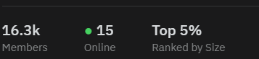

* r/PngTuber

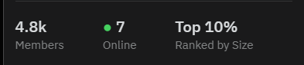

From both of these, r/PngTuber seems to be the most relevant, but r/vtubers has the largest active community.

I think I’ll send my social media post on both.

These are the first two posts on r/vtubers under ‘hot’. They are the most popular recent posts. They show off new models people have made.

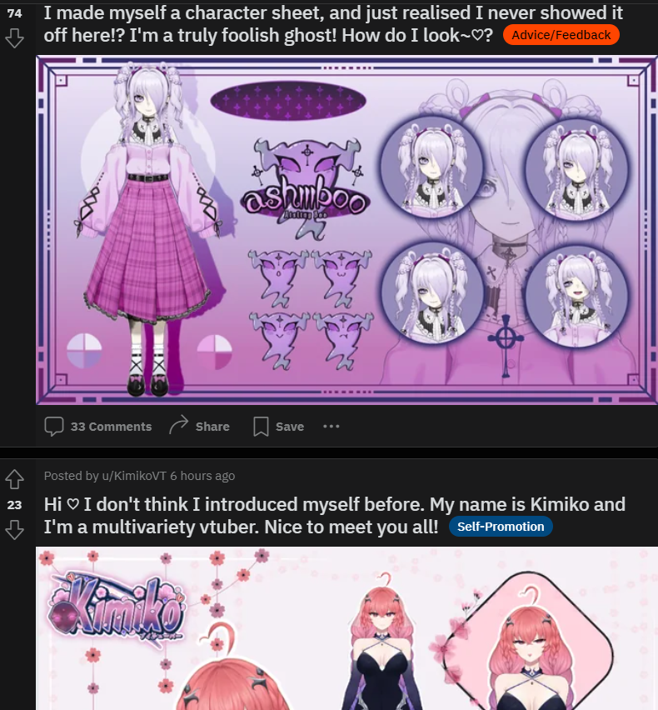

After scrolling for a while, the only other sort of post I found was self-promotion:

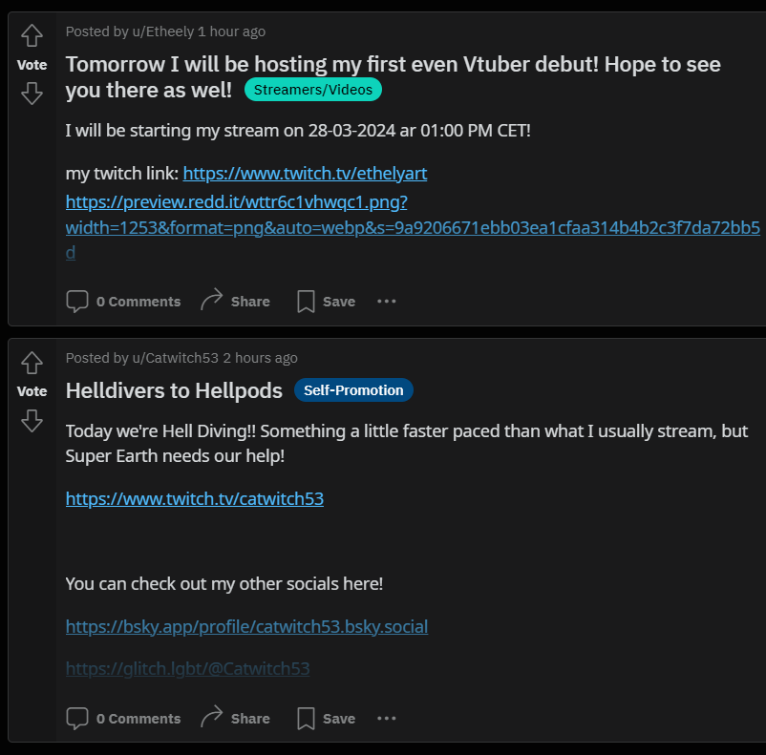

However, checking the rules, there seems to be nothing against showing off new prototypes for tools, and nothing stating that PNGTubing wasn’t allowed, so I seem to be in the clear for r/vtubers.

For r/PngTuber, the top posts are mostly on new models, but there is the occasional post on one of the PNGTuber softwares, as seen below.

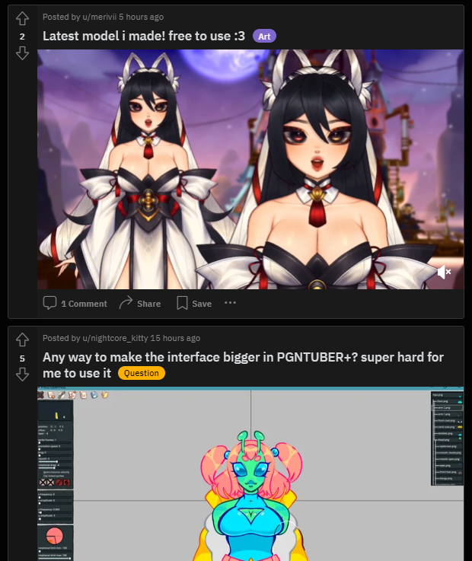

The rules also don’t seem to be a problem.

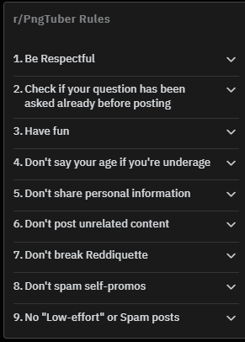

I’m also thinking about doing a small post on r/rpa, promoting my guide for UI.Vision.

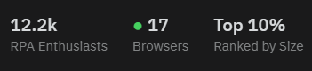

The rules seem to be fine, with the exception of rule 2. Hopefully my guide is advanced enough that it won’t be seen as basic.

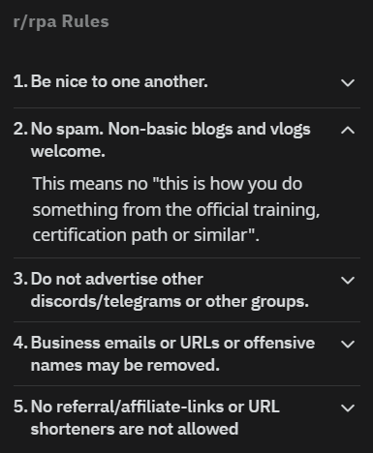

# **Day 81 - Thursday 28/03/2024**

Here we are! The final day. I have until a minute to midnight to get the finishing touches done.

Overnight, I’ve had a bit of hesitation on using the VTubing/PNGTubing subreddits. The canvas handup page says that most people just do a social media post about their guide, maybe r/rpa may be a better bet.

On top of researching the population and rules from before, I looked at a handful of prior posts.

These are the top rated (non-meme) posts of all time in the subreddit.

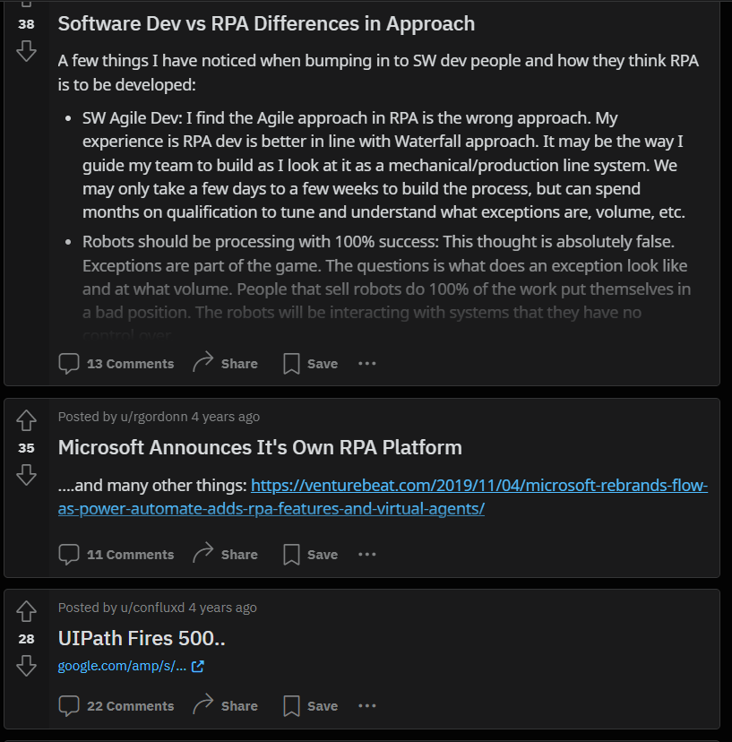

They seem to be a mix of news and stories, all with a great amount of community interaction via comments.

These two are from the most popular posts today:

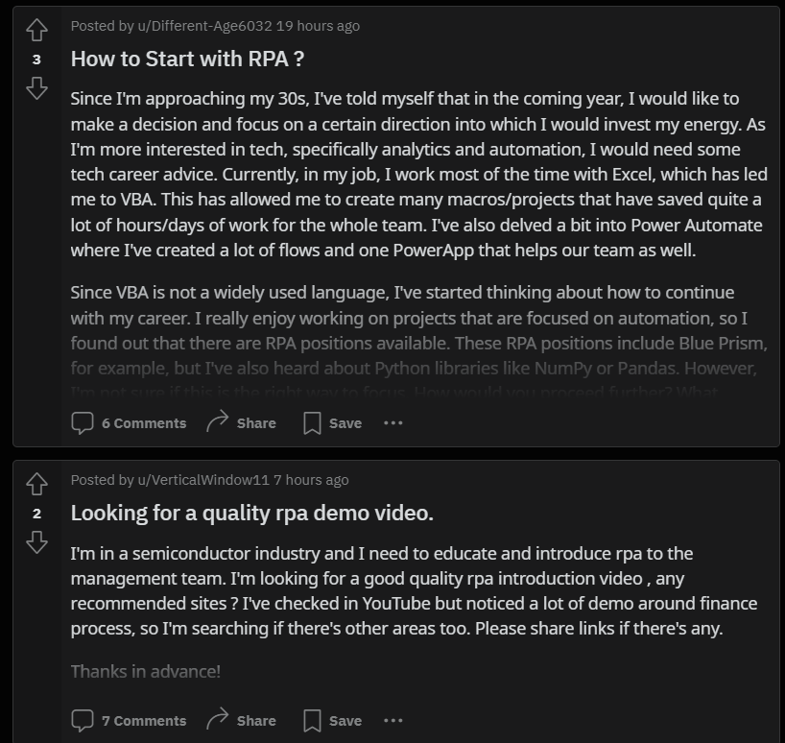

They seem to be semi-formal, with a small personal introduction and with a small thanks at the end. While their upvotes are not hgh, every post consistently gets a good amount of responses.

I then searched for ‘beginner guide’ and ‘walkthrough’ in the subreddit, but only found people asking for one, not one itself.

But, when looking up ‘guide’, I found a very short beginner guide to the concept of rpa in a business setting.   
<https://www.reddit.com/r/rpa/comments/kfo69y/a_miniguide_to_rpa_what_did_i_miss/>

Before getting into the guide, the poster gives a short introduction:

Hi [r/rpa](https://www.reddit.com/r/rpa/),

**I wrote a short mini-guide for companies getting into RPA** (it's for a side project of mine).

**I'd love your feedback!** What did I miss, did I get something wrong? I'm especially interested in hearing about (public?) cases studies that didn't go so well, as I want my piece to cover both sides of the story. I intend to keep this piece relatively short, so obviously I cannot include *everything*.

Text includes links to other resources which are not mine, but intended for those who want to dig in more!

---

As this guide post is successful, I think I will try to emulate this in my own post.

The writer also includes a section on takeaways of the resources in their guide. I have made something similar in my guide, and I could paraphrase those points of my section for this post.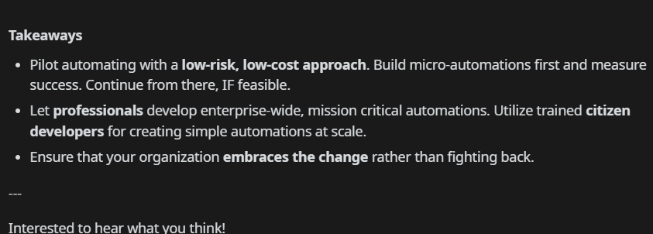

It also ends in a very short conclusion.

Yeah, I think I’ll send my post here.

Title: Introductory Guide to using UI.Vision to Control Desktop Apps

Hello r/rpa!

I’ve recently been using a lot of UI.Vision’s DesktopAutomation XModules, and have made a lengthy and detailed guide on using it to create macros which control more than just web apps.

No prior experience is needed, but the guide will quickly ramp up to more advanced commands. I would recommend using this guide alongside [UI.Vision’s Official Documentation](https://ui.vision/rpa/docs). The guide contains a lot of step-by-step examples and reference pictures, and it should be easy for you to quickly pick up this functionality of UI.Vision to make your own procedures.

The guide also links a lot of further resources you can use to further increase your understanding.

I’d love to hear from any feedback or issues anybody has with the guide!  
  
Here is the finished post:

